

USER INTERFACE DESIGN
23CSE25226
LAB MANUAL
Submitted by
Name | P. Vishal Sri Chandra Varma
Roll no | AV.SC.U4CSE25226
Year/Sem/Section | 1st Year/Sem-2/CSE-C
Credits | 03

Submitted to | DR. Raj Kumar Batchu
Designation | ASST.Proffessor (SL.Grade)
Department | School of computing

INDEX
S.NO | TITLE | PAGE NO: | REMARKS
1 | Week 1.:A.installation of vs code  B.Understanding basics of HTML  C.Understanding basics of HTML tags
2 | Week 2.:A. desing a basic web page with headings ,paragraph,  table, by adding styles
3 | Week 3.:A.Create class timetable using html elements  B.Create a html web page that should display syllabus of  all the subjects as an image format and also, the  timetable
4 | Week 4.:A.Design a registration form using only HTML tags (no  CSS) with proper labels, table alignment, background  color, and borders.  B.Two forms displayed side by side using iframes .one is  login and another registration
week | Week 5.:A.creating a card layout using <div> tag consider  three cards and a button using html and css  B.navigation using iframe (mini website) upon clicking  each buttons the details about that button should be  display on the same page  C.Design amrita login page by showing different  campus on home page.upon clicking on each campus  the details about each campus should be display on  the same page use html and css to design a stylish  webpage
6 | Week 6:A. : Design a responsive e-commerce application using  the grid layout. This application should contain  different categories of products such as electronics,  clothing, home-appliances, books.  B: Design a responsive e-commerce application using  the grid layout. This application should contain  different categories of products such as electronics,  clothing, home-appliances, books. Based on the  category we select corresponding products should be  displayed on the sidebar.
7 | Week 7:A.:create a GitHub account and create a repository in it  and push all the week 6 code files in it.
8 | Week 8:A.:create a web page that displays a square that  continuously rotates 360 using css animation  B.:create a ball that moves up and down continuously  using css animation  C.:create a circle that moves horizontally and rotates  At the same time

WEEK – 1
1.A)AIM : steps to install vs code.
Procedure:
Step 1 :
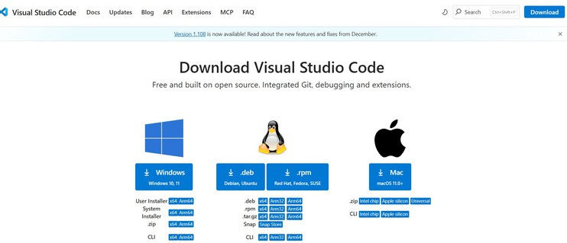
Step 2 :
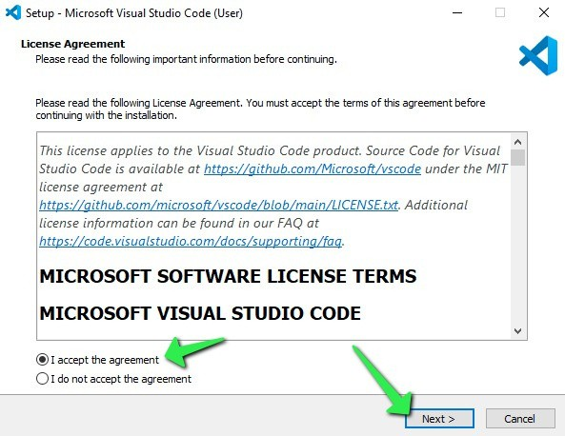
Step 3 :
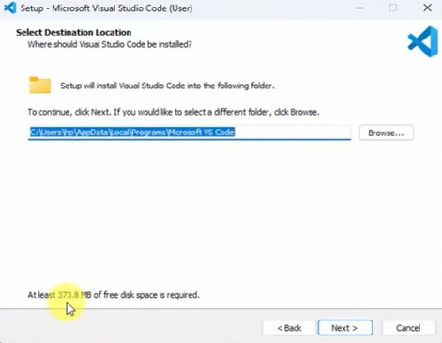
Step 4 :
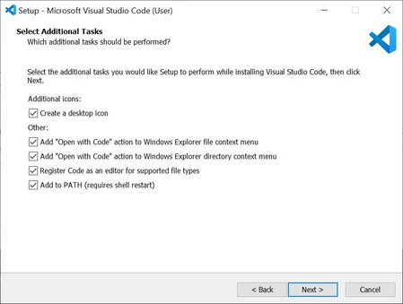
Step 5 :
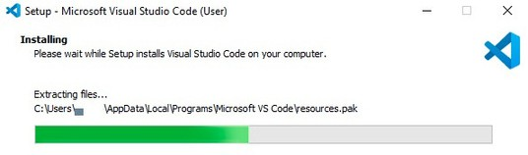
Step 6 :
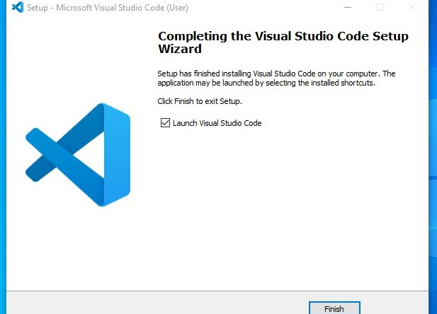
Step 7 :
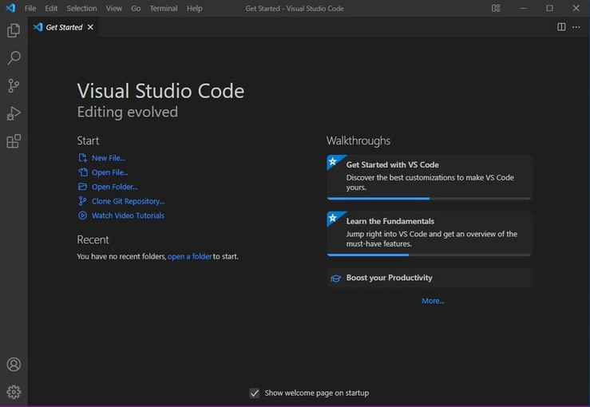

1.B) AIM : To learn the basics of HTML (basics.html)
Program :
UID25226-vishal
<!DOCTYPE html>
<html>
<head>
<title>first web page</title>
</head>
<body>
<h1>happy to learn html</h1>
<p >This is my first sample code</p>
</body>
</html>
Output :
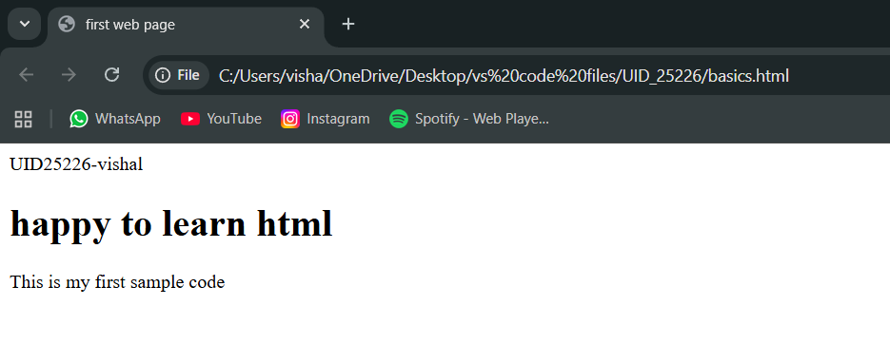

Explanation of the html tags :
. Abbreviation of HTML is hyper text markup language
. HTML is used to create and structure web pages
. HTML acts as skeleton for the web pages
. It tells the web browser what to display and how to display it
. <DOCTYPE html> : the <!DOCTYPE html> element tells the web browser that this an HTML document
or this is the latest version of HTML
. <html> : the <html> element is the root element of an HTML web page
. <head> : the <head> element will contain meta data about the HTML web page
. <title> : the <title> element specifies a title for the HTML Page
. <body> : the <body> element contains all visible content all visible content like text , image , links ,
tables , etc
. <h1> : the <h1> element defines a large heading
. <p> : the <p> element defines a paragraph
. <br> : the <br> element defines a line break. It is an empty tag with no end tag
. style : the HTML style attribute is used a add style to an element such as colour , font , size and more
. <img> : the <img> tag is a fundamental HTML element used to embed an image into web page
. <a> :the HTML <a> element stands for “anchor”, is used to define hyper link
. href : the HTML href attribute is used to add link to the html web page

1.C ) AIM : understanding basic HTML tags
Tags : <p>,<h1>,<img>,<a href>,<br>,<color>, Style and etc...,
Program:
UID-AV.SC.U4CSE25226
<!DOCTYPE html>
<html>
<head>
<title>links</title>
</head>
<body>
<h1 style="color: pink; text-align: center;"
title="amravathi">amrita university</h1>
<p style="color: red;">amrita university is one of the top
university in india<br>one of the best in ap also<br><a
href="https://www.amrita.edu">click here to learn about
amrita</a> </p>
<img src="https://images.seeklogo.com/logo-png/51/2/amrita-
vishwa-vidyapeetham-logo-png_seeklogo-519922.png"
alt="Amrita University" width="500" height="300">
<h2 sytle="color: brown; text-align: center;"
title="amravathi">vit university</h2>
<p style="color: aqua;">vit is one of the good
university<br>one of the best in ap also<br><a
href="https://vit.ac.in/">click here to know about
vit</a></p>
<img

src="https://i.pinimg.com/474x/a7/e2/da/a7e2da54368b7a0a0f53fd
40065053c0.jpg" alt="VIT University" width="500"
height="300">
<h3 style="color: greenyellow; text-align: center;"
title="amravathi">srm university</h3>
<p style="color: blueviolet;">srm in one of the best
universtity in india<br>one of the best in ap also<br><a
href="https://www.srmist.edu.in/">click here about
srm</a></p>
<img src="https://images.seeklogo.com/logo-png/38/1/srm-
institute-of-science-and-technology-logo-png_seeklogo-
381994.png" alt="SRM University" width="500"
height="300">
</body>
</html>
Output:
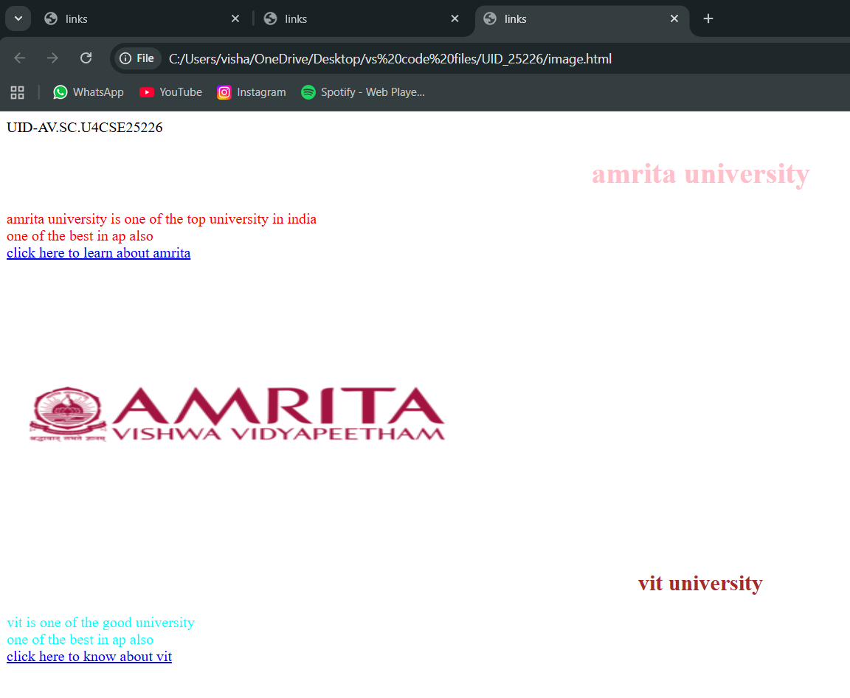
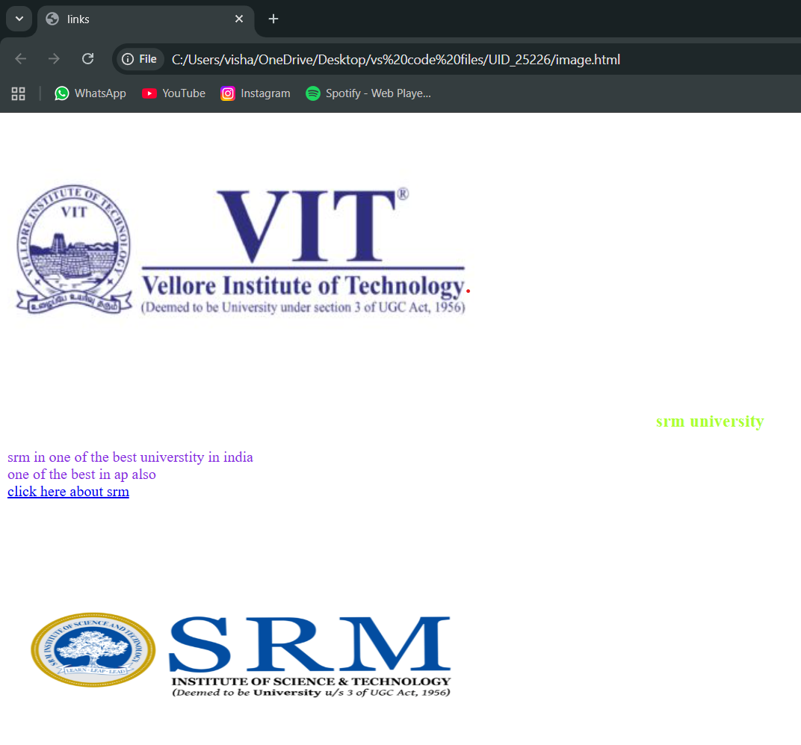
Explanation of the code:
. <head> : the <head> element will contain meta data about the HTML web page
. <title> : the <title> element specifies a title for the HTML Page
. <body> : the <body> element contains all visible content all visible content like text ,
image , links , tables , etc
. <h1> : the <h1> element defines a large heading
. <p> : the <p> element defines a paragraph
. <br> : the <br> element defines a line break. It is an empty tag with no end tag
. style : the HTML style attribute is used a add style to an element such as colour , font ,
size and more
. <img> : the <img> tag is a fundamental HTML element used to embed an image into
web page
. <a> :the HTML <a> element stands for “anchor”, is used to define hyper link
. href : the HTML href attribute is used to add link to the html web page

Week – 2:
2.A)Aim : desing a basic web page with headings ,paragraph,table, by adding styles
Program:
AV.SC.U4CSE25226-UID
<!DOCTYPE html>
<html>
<head>
<title>VISHAL web page</title>
</head>
<body style="background-color: black;background-image:
url(https://drupal.mbauniverse.com/sites/default/files/collegebanner/Amravati-02.jpg);background-repeat: no-repeat;background-size: cover;">
<h1 style="text-align: center;color: ghostwhite;border: 3px solid black;">Amrita Vishwa Vidyapeetham</h1>
<pre style="text-align: center;color: burlywood;font-family: Georgia, 'Times New Roman', Times, serif;font-style: italic;font-size: large;">
Amrita Vishwa Vidyapeetham, Amaravati is a premier, NAAC A++ accredited multi-disciplinary campus located in Andhra Pradesh's capital region.

It offers research-intensive undergraduate and postgraduate programs, focusing on engineering, data science, and management.

The 200-acre lush green campus emphasizes sustainability and modern infrastructure, including advanced laboratories.
</pre>
<table border="2" align="center" bgcolor="lightgray" style="text-align: center;">
<caption style="font-size: x-large;font-weight: bold;color: black; background-color: gray;">All Amrita campus Details</caption>
<tr style="color: red;font-style: bold;font-size: large;">
<th>S.No</th>
<th>Campus Name</th>
<th>location</th>
<th>Department</th>
<th>faculty name</th>
<th>Contact No,E mail</th>
</tr>
<tr style="color: rgb(10, 10, 10);font-style: italic;font-size: medium;">
<td>1.</td>
<td>AMRAVTHI</td>
<td>amaravati</td>
<td>UID-CSE</td>
<td>DR.Raj kumar batchu</td>
<td>94949 99944</td>
</tr>
<tr style="color: rgb(10, 10, 10);font-style: italic;font-size: medium;">
<td>2.</td>
<td>Amrithapuri</td>
<td>amritapuri</td>
<td>UID-CSE</td>
<td>DR.Ajay kumar</td>
<td>84848 44888</td>
</tr>
<tr style="color: rgb(10, 10, 10);font-style: italic;font-size: medium;">
<td>3.</td>
<td>Chennai</td>
<td>chennai</td>
<td>UID-CSE</td>
<td>DR.Suresh babu</td>
<td>96969 99969</td>
</tr>
</table>
<button url="https://www.amrita.edu/campus/amaravati/" style="display: block;margin: auto;margin-top: 20px;padding: 10px 20px;font-size: large;background-color: lightgray;color: black;border: 2px solid black;border-radius: 5px;cursor: pointer;" onclick="alert('Welcome to Amrita Vishwa Vidyapeetham!')">for more about amrita</button>
</body>
</html>

Output :
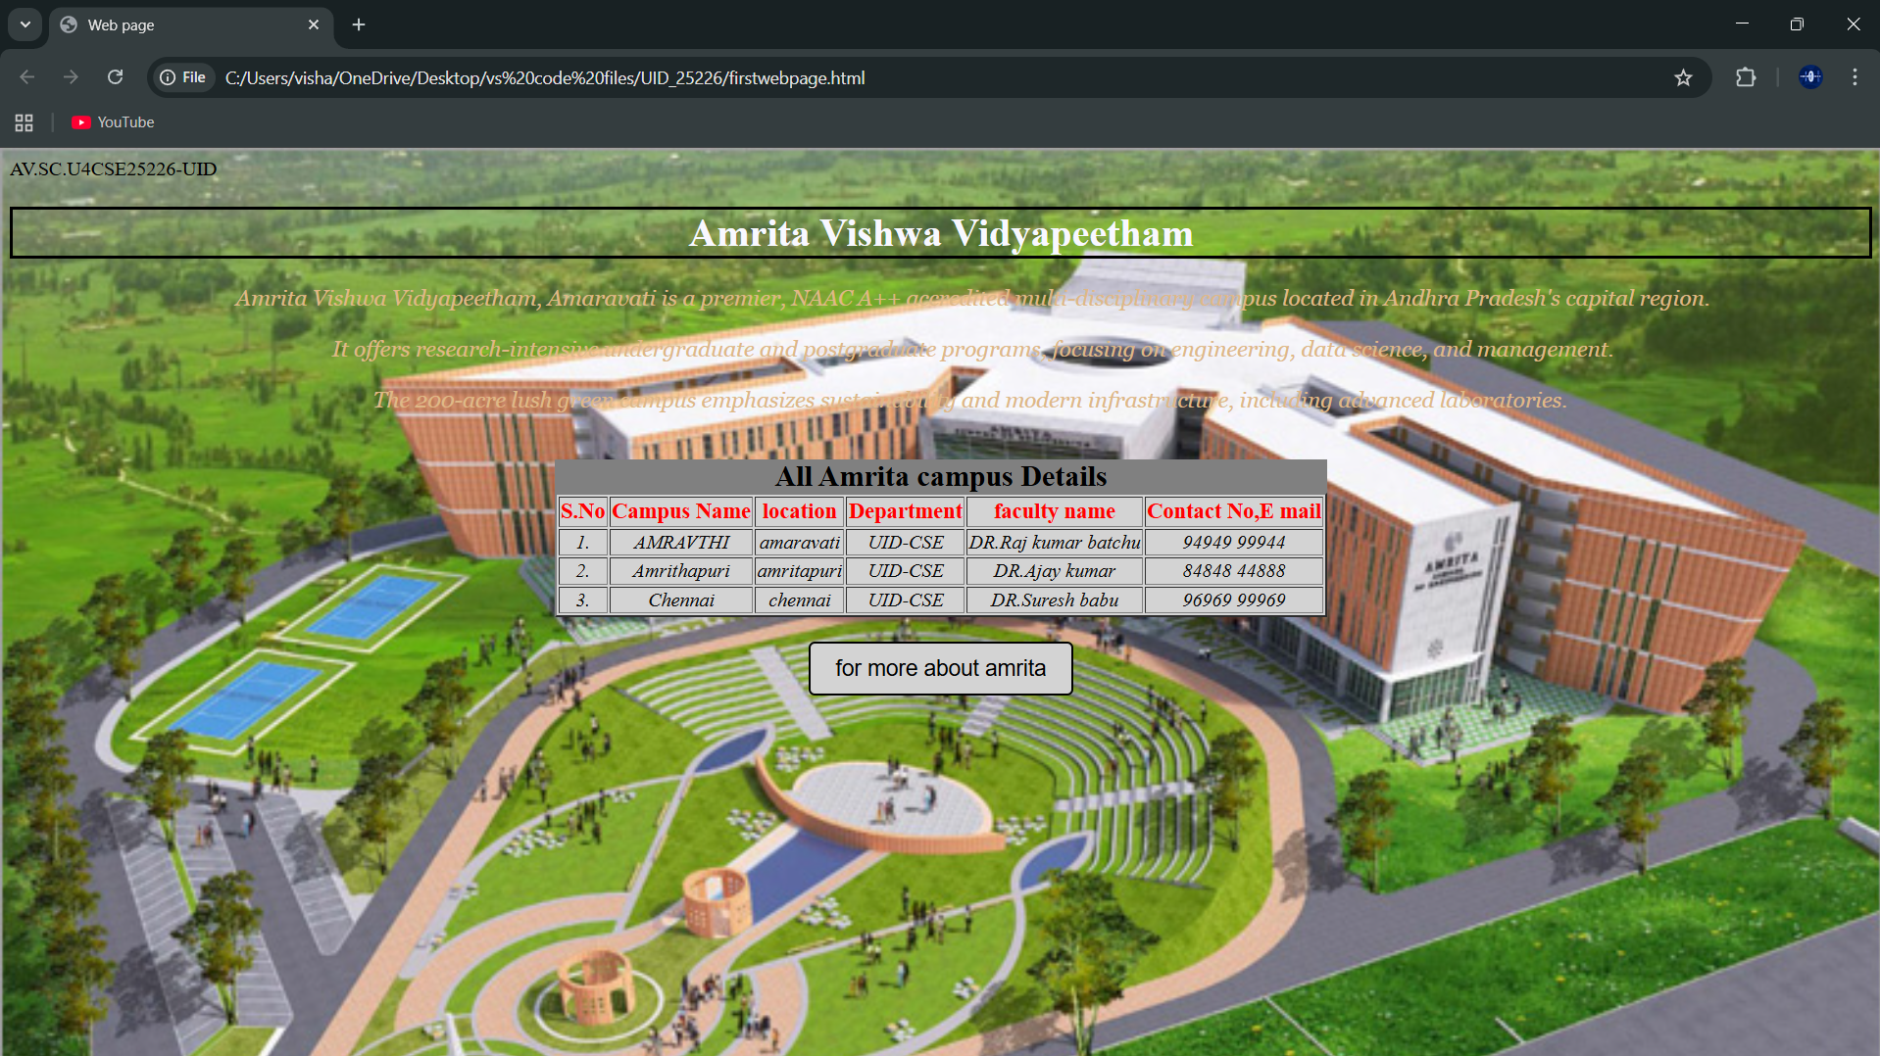
Explanation :
. <DOCTYPE html> : the <!DOCTYPE html> element tells the web browser that this an HTML document
or this is the latest version of HTML
. <html> : the <html> element is the root element of an HTML web page
. <head> : the <head> element will contain meta data about the HTML web page
. <title> : the <title> element specifies a title for the HTML Page
. <body> : the <body> element contains all visible content all visible content like text , image , links ,
tables , etc
. <table>: the element <table> is used to create a table
. <tr>: the element <tr> creates a new row in the table
. <th>: the element <th> create a new heading inside the table
. <td>: the element <td> fill the columns in the row
. <button>: the element <button> is used for button .
The style attribute is used to add style the elements in the html webpage and url attribute for adding the url or link to the button

Week-3
3.A)Aim : to create a time table using html by using tags like
<table>,<td>,<th>,<tr>,and using style attribute in it
Program :
UID-AV.SC.U4CSE25226
<!DOCTYPE html>
<html>
<head>
<title>CSE Timetable</title>
</head>
<body style="font-family: Arial; margin:20px;">
<h2 style="text-align:center;">Master Time Table</h2>
<h3 style="text-align:center;">CSE II Semester – C Section</h3>
<table border="1" width="100%" cellpadding="6" cellspacing="0">
<tr>
<td><b>Dept:</b> CSE</td>
<td><b>Class:</b> B.Tech CSE-C</td>
<td><b>Semester:</b> II</td>
<td><b>Room:</b> 512</td>
</tr>
<tr>
<td colspan="2">
<b>Class Advisor 1:</b> Mr. Budati Jaya Lakshminarayana<br>
bj_lakshminarayana@amrita.edu<br>
+91-7989795768
</td>
<td colspan="2">
<b>Class Advisor 2:</b> Dr. Arun Kumar S<br>
s_arunkumar@av.amrita.edu<br>
+91-9840857202
</td>
</tr>
</table>
<br>
<table border="1" width="100%" cellpadding="6" cellspacing="0" style="text-align:center;">
<tr>
<th rowspan="2">Time/Day</th>
<th>08:55-09:45</th>
<th>09:45-10:35</th>
<th style="background:yellow; writing-mode: sideways-lr;" rowspan="7">Break</th>
<th>10:45-11:35</th>
<th>11:35-12:25</th>
<th>12:25-01:15</th>
<th style="background:yellow; writing-mode: sideways-lr;" rowspan="7">Lunch</th>
<th>02:10-03:00</th>
<th style="background:yellow; writing-mode: sideways-lr;" rowspan="7">Break</th>
<th>03:10-04:00</th>
<th>04:00-04:50</th>
</tr>
<tr>
<th>slot1</th>
<th>slot2</th>
<th>slot3</th>
<th>slot4</th>
<th>slot5</th>
<th>slot6</th>
<th>slot7</th>
<th>slot8</th>
</tr>
<tr>
<th>Monday</th>
<td colspan="2">23MAT116 Discrete Mathematics Lab</td>
<td>23PHY115 Modern Physics</td>
<td>23CSE111 OOP</td>
<td>22ADM111 GGI</td>
<td >GGI (P)</td>
<td colspan="2">Library / Sports</td>
</tr>
<tr>
<th>Tuesday</th>
<td colspan="2">23CSE113 UI Design Lab</td>
<td>Linear Algebra</td>
<td>Discrete Mathematics</td>
<td style="color:red;"><b>COUNSELLING</b></td>
<td>Manufacturing Practice Lab</td>
<td colspan="2">Manufacturing Practice Lab</td>
</tr>
<tr>
<th>Wednesday</th>
<td>Modern Physics</td>
<td>UI Design</td>
<td colspan="2">Linear Algebra Lab</td>
<td style="color:red;"><b>COUNSELLING</b></td>
<td >Library</td>
<td>GGI</td>
<td>Library / Sports</td>
</tr>
<tr>
<th>Thursday</th>
<td>OOP</td>
<td>Discrete Mathematics</td>
<td colspan="2">OOP Lab</td>
<td>Linear Algebra</td>
<td >Library</td>
<td colspan="2">Library / Sports</td>
</tr>
<tr>
<th>Friday</th>
<td>OOP</td>
<td>Discrete Mathematics</td>
<td>Modern Physics</td>
<td>UI Design</td>
<td>Linear Algebra</td>
<td >Library</td>
<td colspan="2">Library / Sports</td>
</tr>
</table>
<br>
<table border="1" width="100%" cellpadding="6" cellspacing="0">
<tr>
<th>Course code</th>
<th>Course Name</th>
<th>Faculty name</th>
<th>L-T-P</th>
<th>Credits</th>
</tr>
<tr>
<td>23MAT116</td>
<td>Discrete Mathematics</td>
<td>Dr.bixapathi</td>
<td>3-0-0</td>
<td>3</td>
</tr>
<tr>
<td>23PHY115</td>
<td>Modern Physics</td>
<td>Dr.sowmya</td>
<td>3-0-0</td>
<td>3</td>
</tr>
<tr>
<td>23CSE111</td>
<td>OOP</td>
<td>Dr.satya rajendra singh</td>
<td>3-0-0</td>
<td>3</td>
</tr>
<tr>
<td>22ADM111</td>
<td>GGI</td>
<td>DR.siva panuganti</td>
<td>2-0-0</td>
<td>2</td>
</tr>
<tr>
<td>23CSE113</td>
<td>UI Design</td>
<td>Dr.rajshekar batchu</td>
<td>3-0-0</td>
<td>3</td>
</tr>
<tr>
<td>23MEE115</td>
<td>Manufacturing Practice</td>
<td>Dr.sathies</td>
<td>0-0-3</td>
<td>1</td>
</tr>
<tr>
<td>23MAT116</td>
<td>Discrete Mathematics Lab</td>
<td>Dr.Thota srinivas rao</td>
<td>0-0-2</td>
<td>1</td>
</tr>
</table>
</body>
</html>
Output :
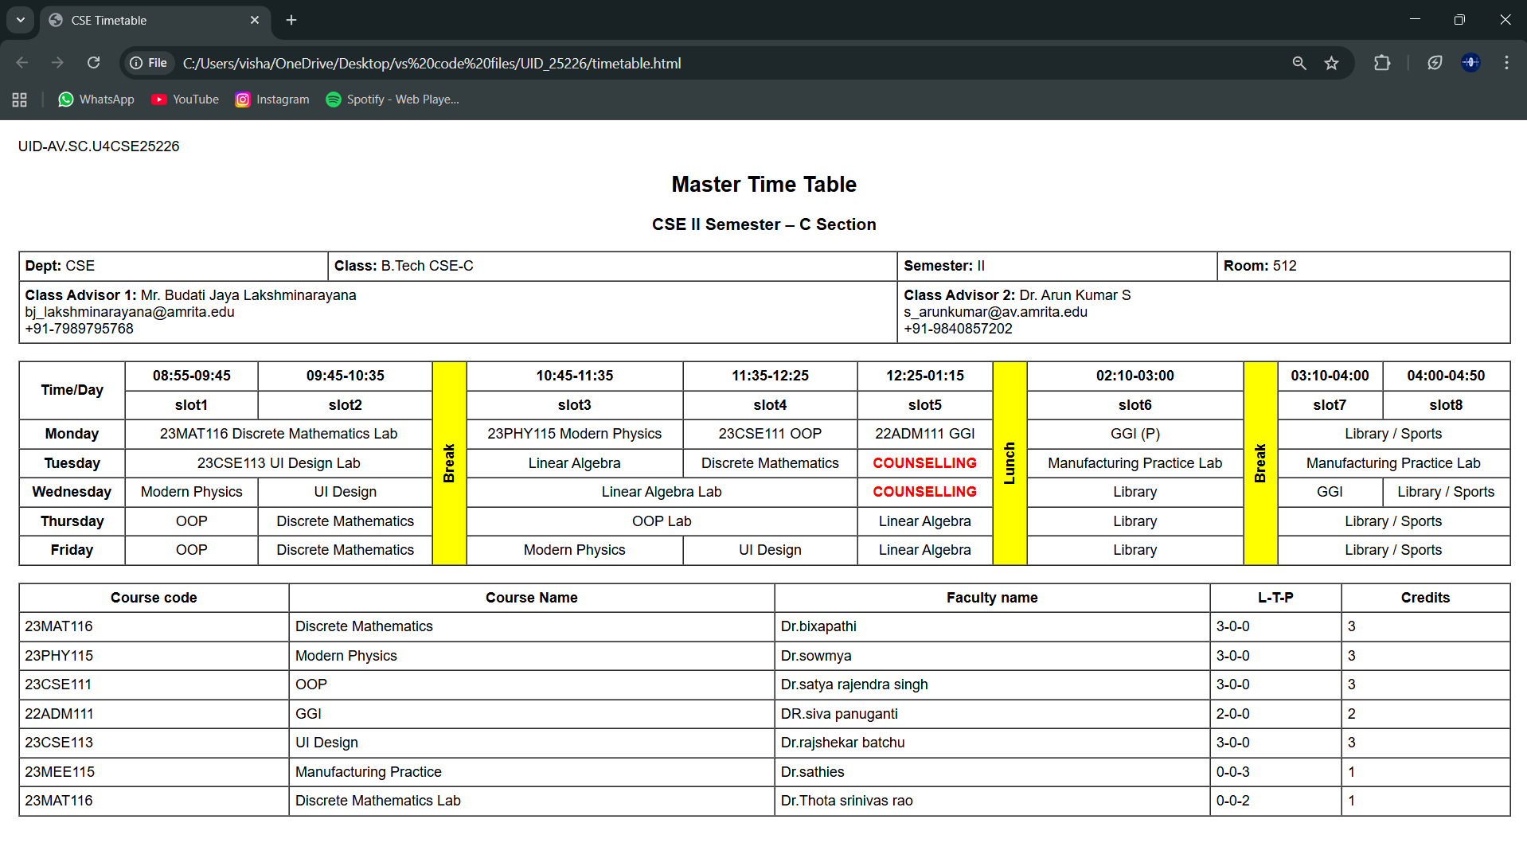
Explanation :
<DOCTYPE html> : the <!DOCTYPE html> element tells the web browser that this an HTML document
or this is the latest version of HTML
<html> : the <html> element is the root element of an HTML web page
<head> : the <head> element will contain meta data about the HTML web page
<title> : the <title> element specifies a title for the HTML Page
<body> : the <body> element contains all visible content all visible content like text , image , links ,
tables , etc
we use this tags in addition to the above tags that we used in other programs
<h> : we used <h> element for heading
<p> : we used <p> element for the paragraph
<table>: the element <table> is used to create a table
<tr>: the element <tr> creates a new row in the table
<th>: the element <th> create a new heading inside the table
<td>: the element <td> fill the columns in the row
And we used colspan and rowspan to combine two rows or colums in the table. And we used the style attribute in both the td and tr tags to get the text in vertical way and colour for the blocks and alignment of text.

3.B)Aim: to create the timetable with the respective syllabus at the end of the page.
In this we use the combined form of the week-1, 3rd one and week-2 1st one
Program :
UID-AV.SC.U4CSE25226
<!DOCTYPE html>
<html>
<head>
<title>CSE Timetable</title>
</head>
<body style="font-family: Arial; margin:20px;">
<h2 style="text-align:center;">Master Time Table</h2>
<h3 style="text-align:center;">CSE II Semester – C Section</h3>
<table border="1" width="100%" cellpadding="6" cellspacing="0">
<tr>
<td><b>Dept:</b> CSE</td>
<td><b>Class:</b> B.Tech CSE-C</td>
<td><b>Semester:</b> II</td>
<td><b>Room:</b> 512</td>
</tr>
<tr>
<td colspan="2">
<b>Class Advisor 1:</b> Mr. Budati Jaya Lakshminarayana<br>
bj_lakshminarayana@amrita.edu<br>
+91-7989795768
</td>
<td colspan="2">
<b>Class Advisor 2:</b> Dr. Arun Kumar S<br>
s_arunkumar@av.amrita.edu<br>
+91-9840857202
</td>
</tr>
</table>
<br>
<table border="1" width="100%" cellpadding="6" cellspacing="0" style="text-align:center;">
<tr>
<th rowspan="2">Time/Day</th>
<th>08:55-09:45</th>
<th>09:45-10:35</th>
<th style="background:yellow; writing-mode: sideways-lr;" rowspan="7">Break</th>
<th>10:45-11:35</th>
<th>11:35-12:25</th>
<th>12:25-01:15</th>
<th style="background:yellow; writing-mode: sideways-lr;" rowspan="7">Lunch</th>
<th>02:10-03:00</th>
<th style="background:yellow; writing-mode: sideways-lr;" rowspan="7">Break</th>
<th>03:10-04:00</th>
<th>04:00-04:50</th>
</tr>
<tr>
<th>slot1</th>
<th>slot2</th>
<th>slot3</th>
<th>slot4</th>
<th>slot5</th>
<th>slot6</th>
<th>slot7</th>
<th>slot8</th>
</tr>
<tr>
<th>Monday</th>
<td colspan="2">23MAT116 Discrete Mathematics Lab</td>
<td>23PHY115 Modern Physics</td>
<td>23CSE111 OOP</td>
<td>22ADM111 GGI</td>
<td >GGI (P)</td>
<td colspan="2">Library / Sports</td>
</tr>
<tr>
<th>Tuesday</th>
<td colspan="2">23CSE113 UI Design Lab</td>
<td>Linear Algebra</td>
<td>Discrete Mathematics</td>
<td style="color:red;"><b>COUNSELLING</b></td>
<td>Manufacturing Practice Lab</td>
<td colspan="2">Manufacturing Practice Lab</td>
</tr>
<tr>
<th>Wednesday</th>
<td>Modern Physics</td>
<td>UI Design</td>
<td colspan="2">Linear Algebra Lab</td>
<td style="color:red;"><b>COUNSELLING</b></td>
<td >Library</td>
<td>GGI</td>
<td>Library / Sports</td>
</tr>
<tr>
<th>Thursday</th>
<td>OOP</td>
<td>Discrete Mathematics</td>
<td colspan="2">OOP Lab</td>
<td>Linear Algebra</td>
<td >Library</td>
<td colspan="2">Library / Sports</td>
</tr>
<tr>
<th>Friday</th>
<td>OOP</td>
<td>Discrete Mathematics</td>
<td>Modern Physics</td>
<td>UI Design</td>
<td>Linear Algebra</td>
<td >Library</td>
<td colspan="2">Library / Sports</td>
</tr>
</table>
<br>
<table border="1" width="100%" cellpadding="6" cellspacing="0">
<tr>
<th>Course code</th>
<th>Course Name</th>
<th>Faculty name</th>
<th>L-T-P</th>
<th>Credits</th>
</tr>
<tr>
<td>23MAT116</td>
<td>Discrete Mathematics</td>
<td>Dr.bixapathi</td>
<td>3-0-0</td>
<td>3</td>
</tr>
<tr>
<td>23PHY115</td>
<td>Modern Physics</td>
<td>Dr.sowmya</td>
<td>3-0-0</td>
<td>3</td>
</tr>
<tr>
<td>23CSE111</td>
<td>OOP</td>
<td>Dr.satya rajendra singh</td>
<td>3-0-0</td>
<td>3</td>
</tr>
<tr>
<td>22ADM111</td>
<td>GGI</td>
<td>DR.siva panuganti</td>
<td>2-0-0</td>
<td>2</td>
</tr>
<tr>
<td>23CSE113</td>
<td>UI Design</td>
<td>Dr.rajshekar batchu</td>
<td>3-0-0</td>
<td>3</td>
</tr>
<tr>
<td>23MEE115</td>
<td>Manufacturing Practice</td>
<td>Dr.sathies</td>
<td>0-0-3</td>
<td>1</td>
</tr>
<tr>
<td>23MAT116</td>
<td>Discrete Mathematics Lab</td>
<td>Dr.Thota srinivas rao</td>
<td>0-0-2</td>
<td>1</td>
</tr>
</table>
<p style="background-color: yellow;">Discrete Mathematics</p>
<img src="C:\Users\visha\OneDrive\Pictures\Screenshots\Screenshot 2026-02-04 145225.png">
<p style="background-color: yellow;">Linear Algebra</p>
<img src="C:\Users\visha\OneDrive\Pictures\Screenshots\Screenshot 2026-02-04 145704.png">
<p style="background-color: yellow;">object oriented programing</p>
<img src="C:\Users\visha\OneDrive\Pictures\Screenshots\Screenshot 2026-02-04 145806.png">
<p style="background-color: yellow;">Modren Physics</p>
<img src="C:\Users\visha\OneDrive\Pictures\Screenshots\Screenshot 2026-02-04 145903.png">
<p style="background-color: yellow;">UI Design</p>
<img src="C:\Users\visha\OneDrive\Pictures\Screenshots\Screenshot 2026-02-04 145936.png">
<p style="background-color: yellow;">Manufacturing Practice</p>
<img src="C:\Users\visha\OneDrive\Pictures\Screenshots\Screenshot 2026-02-04 150010.png">
<p style="background-color: yellow;">GGI</p>
<img src="C:\Users\visha\OneDrive\Pictures\Screenshots\Screenshot 2026-02-04 150101.png">
</body>
</html>

Output: 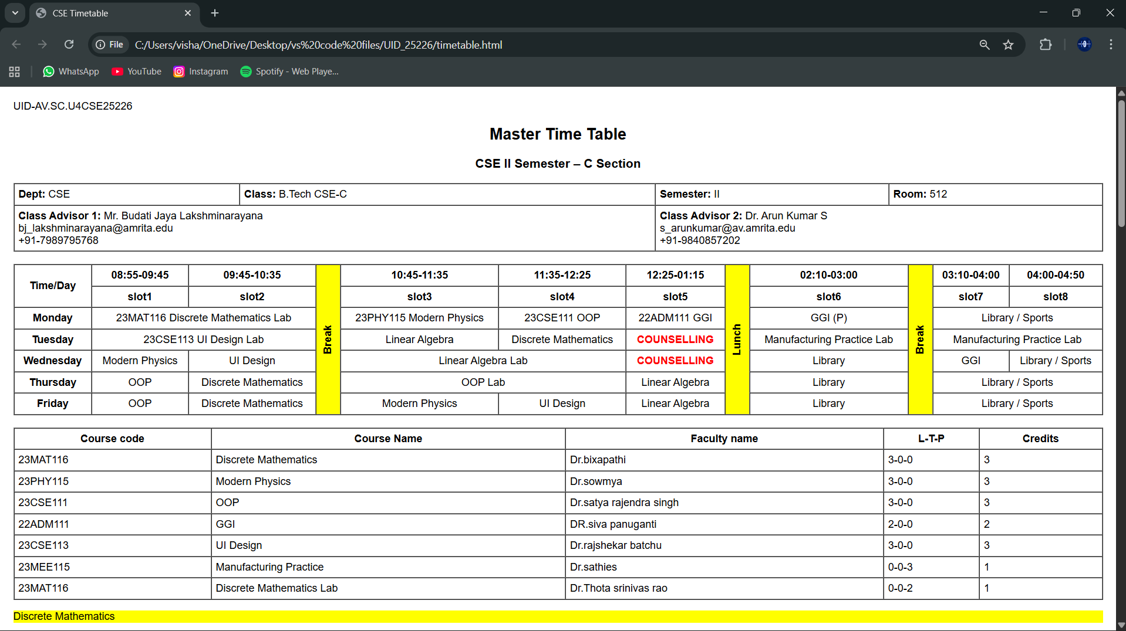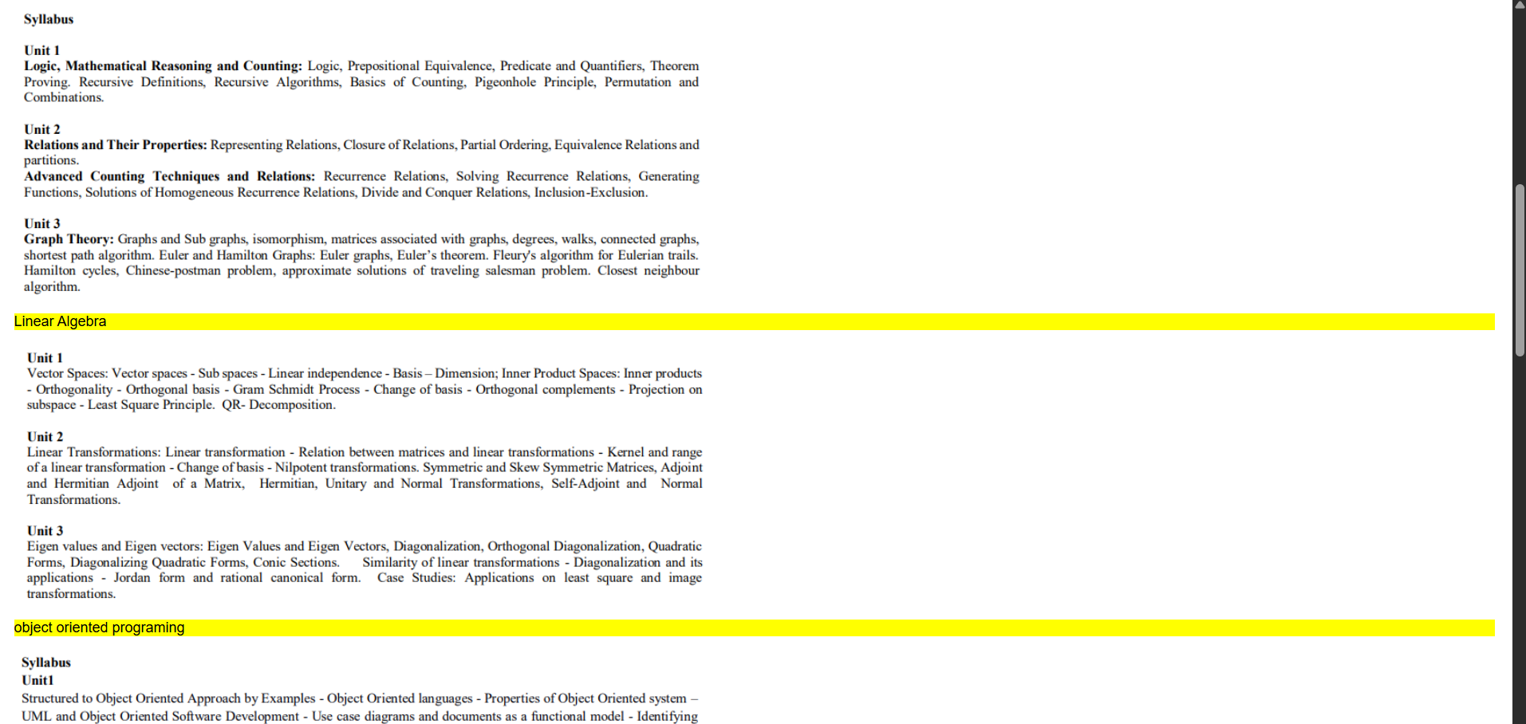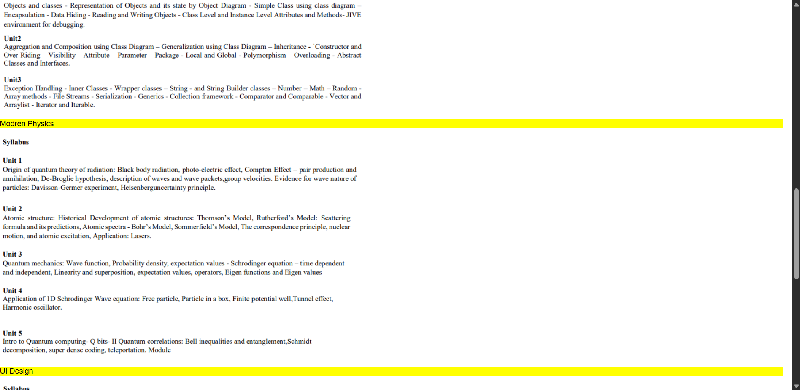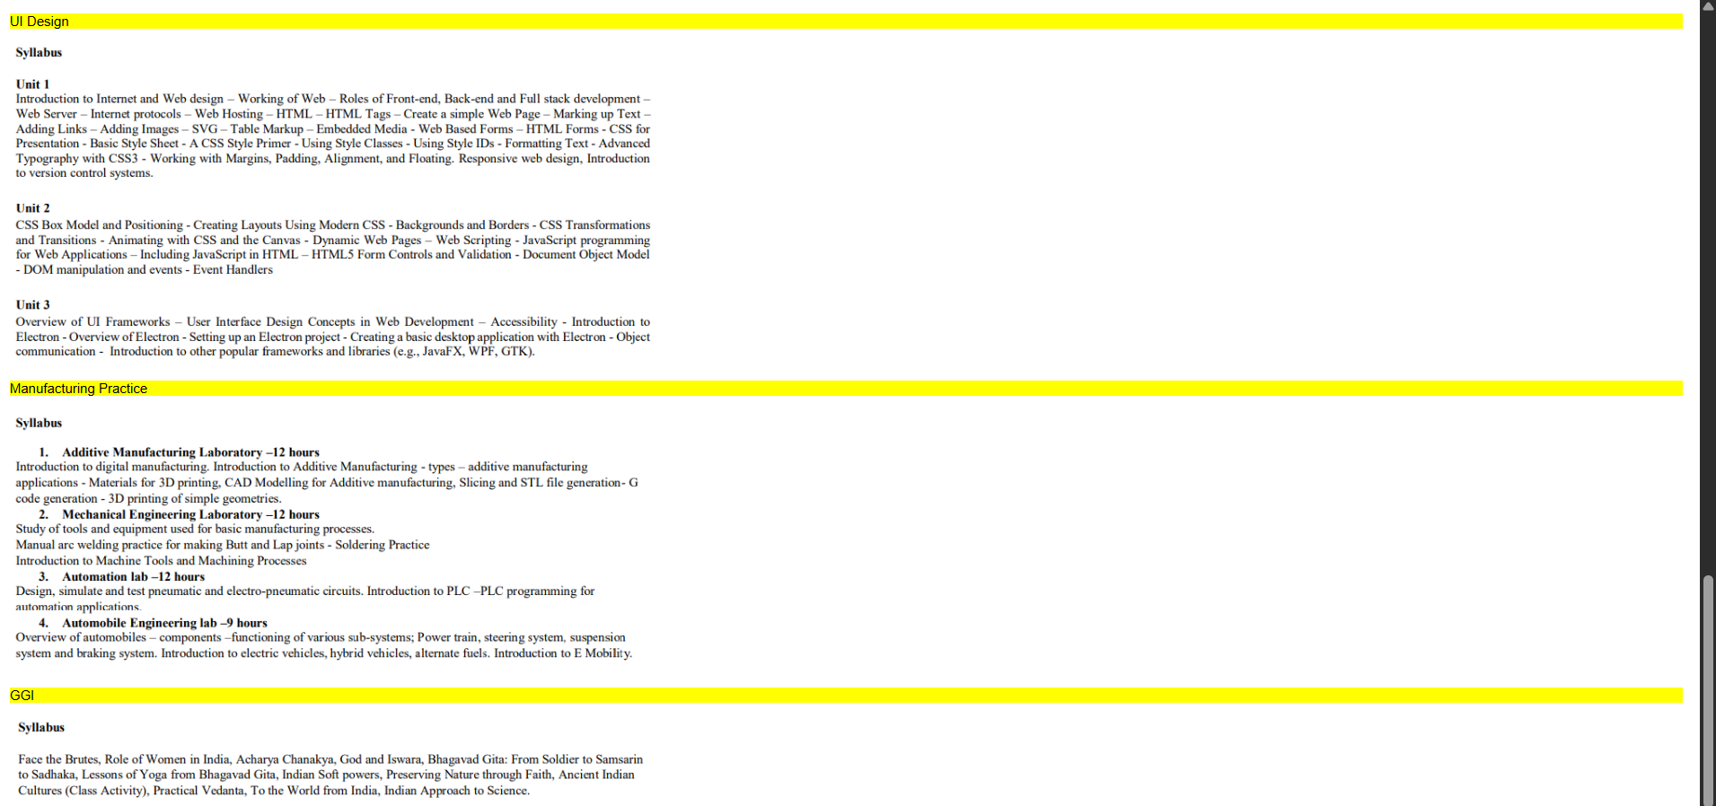-
Explanation:
<DOCTYPE html> : the <!DOCTYPE html> element tells the web browser that this an HTML document
or this is the latest version of HTML
<html> : the <html> element is the root element of an HTML web page
<head> : the <head> element will contain meta data about the HTML web page
<title> : the <title> element specifies a title for the HTML Page
<body> : the <body> element contains all visible content all visible content like text , image , links , tables , etc
In this we use the combined form of the week-1, 3rd one and week-3 1st one . In detail we use the table tags that we used in week-2, 1st program and the image elements from week-1 3rd program by combining both of those tags we get this .
<h> : we used <h> element for heading
<p> : we used <p> element for the paragraph
<table> : we used <table> element for the creation of the table
<tr> : we used <tr> element for creation of row in the table
<td> : we used <td> element for creation of table details
<th> : we used <th> element for creation of table headings
<img> : we used <img> element for adding the images into the web page
And we used colspan and rowspan for combining rows and coloums and scr attribute for adding the image link and we also used style attribute for the colurs and the vertical text and alignment of text.
Week – 4:
4.A)Aim: Design a registration form using only HTML tags (no CSS) with proper labels, table
alignment, background color, and borders.
Program :
UID-AV.SC.U4CSE25226
<!DOCTYPE html>
<html>
<head>
<title>College Admission Registration</title>
</head>
<body bgcolor="#e6e6fa">
<center>
<h2>College Admission Registration</h2>
<table border="2" cellpadding="8" cellspacing="0" bgcolor="#ffffff">
<tr>
<td><label for="name">Full Name:</label></td>
<td><input type="text" id="name" name="name" size="40"></td>
</tr>
<tr>
<td><label for="email">Email:</label></td>
<td><input type="email" id="email" name="email" size="40"></td>
</tr>
<tr>
<td><label for="phone">Phone Number:</label></td>
<td><input type="tel" id="phone" name="phone" size="40"></td>
</tr>
<tr>
<td>Gender:</td>
<td>
<input type="radio" name="gender" value="male"> Male
<input type="radio" name="gender" value="female"> Female
<input type="radio" name="gender" value="other"> Other
</td>
</tr>
<tr>
<td><label for="course">Course Applying For:</label></td>
<td>
<select id="course" name="course">
<option>B.Tech</option>
<option>B.Sc</option>
<option>B.Com</option>
<option>BA</option>
</select>
</td>
</tr>
<tr>
<td>Hobbies:</td>
<td>
<input type="checkbox" name="hobby" value="sports"> Sports
<input type="checkbox" name="hobby" value="music"> Music
<input type="checkbox" name="hobby" value="reading"> Reading
</td>
</tr>
<tr>
<td><label for="dob">Date of Birth:</label></td>
<td><input type="date" id="dob" name="dob"></td>
</tr>
<tr>
<td><label for="file">Upload Certificates:</label></td>
<td><input type="file" id="file" name="file"></td>
</tr>
<tr>
<td><label for="address">Address:</label></td>
<td>
<textarea id="address" name="address" rows="4" cols="35"></textarea>
</td>
</tr>
<tr align="center">
<td colspan="2">
<input type="submit" value="Submit">
<input type="reset" value="Reset">
</td>
</tr>
</table>
</center>
</body>
</html>

Output :
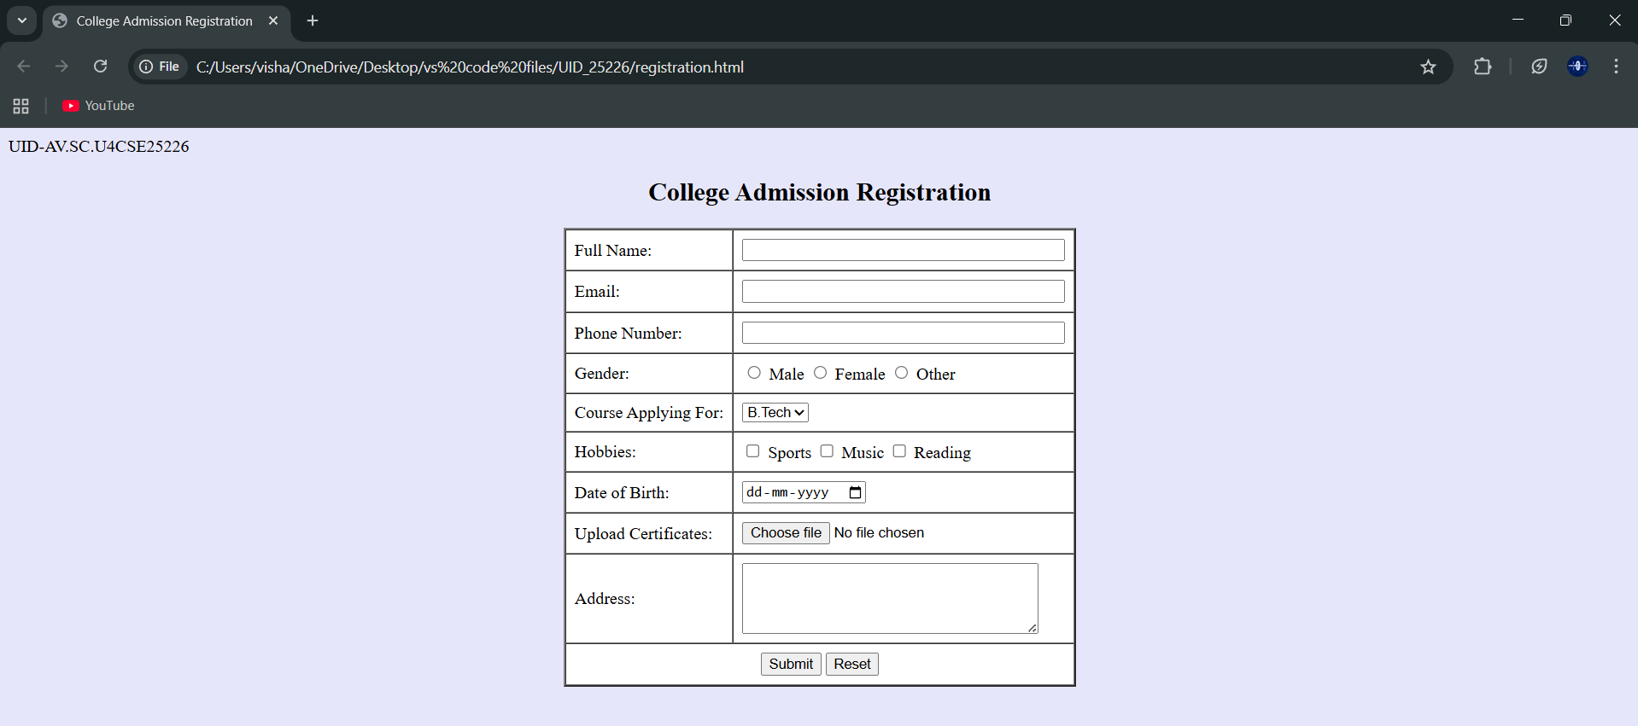
Explanation :
<DOCTYPE html> : the <!DOCTYPE html> element tells the web browser that this an HTML document
or this is the latest version of HTML
<html> : the <html> element is the root element of an HTML web page
<head> : the <head> element will contain meta data about the HTML web page
<title> : the <title> element specifies a title for the HTML Page
<body> : the <body> element contains all visible content all visible content like text , image , links ,
tables , etc
<h> : we used <h> element for heading
<p> : we used <p> element for the paragraph
<table>: the element <table> is used to create a table
<tr>: the element <tr> creates a new row in the table
<th>: the element <th> create a new heading inside the table
<td>: the element <td> fill the columns in the row
<label>:we used <label> element for linking the input to specific id name and we use for attribute for it
<input>:we use <input> element for the input elements in the forms
<select>:we use <select> element for creation of drop box
<option>:we use <option> element for creating the options in the drop box
And we use style attribute for styling and designing the webpage and type for selecting the type of input that is going to In it and for and id tag is used to link the input to label.

4.B)Aim: Two forms displayed side by side using iframes .one is login and another registration
Program :
Main code with Iframes:
UID-AV.SC.U4CSE25226
<!DOCTYPE html>
<html>
<head>
<title>Two Forms Using Iframes</title>
</head>
<body bgcolor="#e6e6cc">
<h2 align="center">Two Forms Displayed Using Iframes</h2>
<table align="center" cellpadding="20">
<tr>
<td>
<iframe src="login.html" width="350" height="300"></iframe>
</td>
<td>
<iframe src="register.html" width="350" height="300"></iframe>
</td>
</tr>
</table>
</body>
</html>
Login.html:
UID-AV.SC.U4CSE25226
<!DOCTYPE html>
<html>
<head>
<title>Login Form</title>
</head>
<body>
<h3 align="center">User Login</h3>
<form>
<table border="1" align="center" cellpadding="8">
<tr>
<td><label for="username">Username:</label></td>
<td><input type="text" id="username" name="username"></td>
</tr>
<tr>
<td><label for="password">Password:</label></td>
<td><input type="password" id="password" name="password"></td>
</tr>
<tr align="center">
<td colspan="2">
<input type="submit" value="Login">
</td>
</tr>
</table>
</form>
</body>
</html>
Register.html:
UID-AV.SC.U4CSE25226
<!DOCTYPE html>
<html>
<head>
<title>Registration Form</title>
</head>
<body>
<h3 align="center">User Registration</h3>
<form>
<table border="1" align="center" cellpadding="8">
<tr>
<td><label for="name">Full Name:</label></td>
<td><input type="text" id="name" name="name"></td>
</tr>
<tr>
<td><label for="email">Email:</label></td>
<td><input type="email" id="email" name="email"></td>
</tr>
<tr>
<td><label for="phone">Phone:</label></td>
<td><input type="tel" id="phone" name="phone"></td>
</tr>
<tr>
<td>Password:</td>
<td><input type="password" name="password"></td>
</tr>
<tr align="center">
<td colspan="2">
<input type="submit" value="Register">
<input type="reset" value="Reset">
</td>
</tr>
</table>
</form>
</body>
</html>
Output :
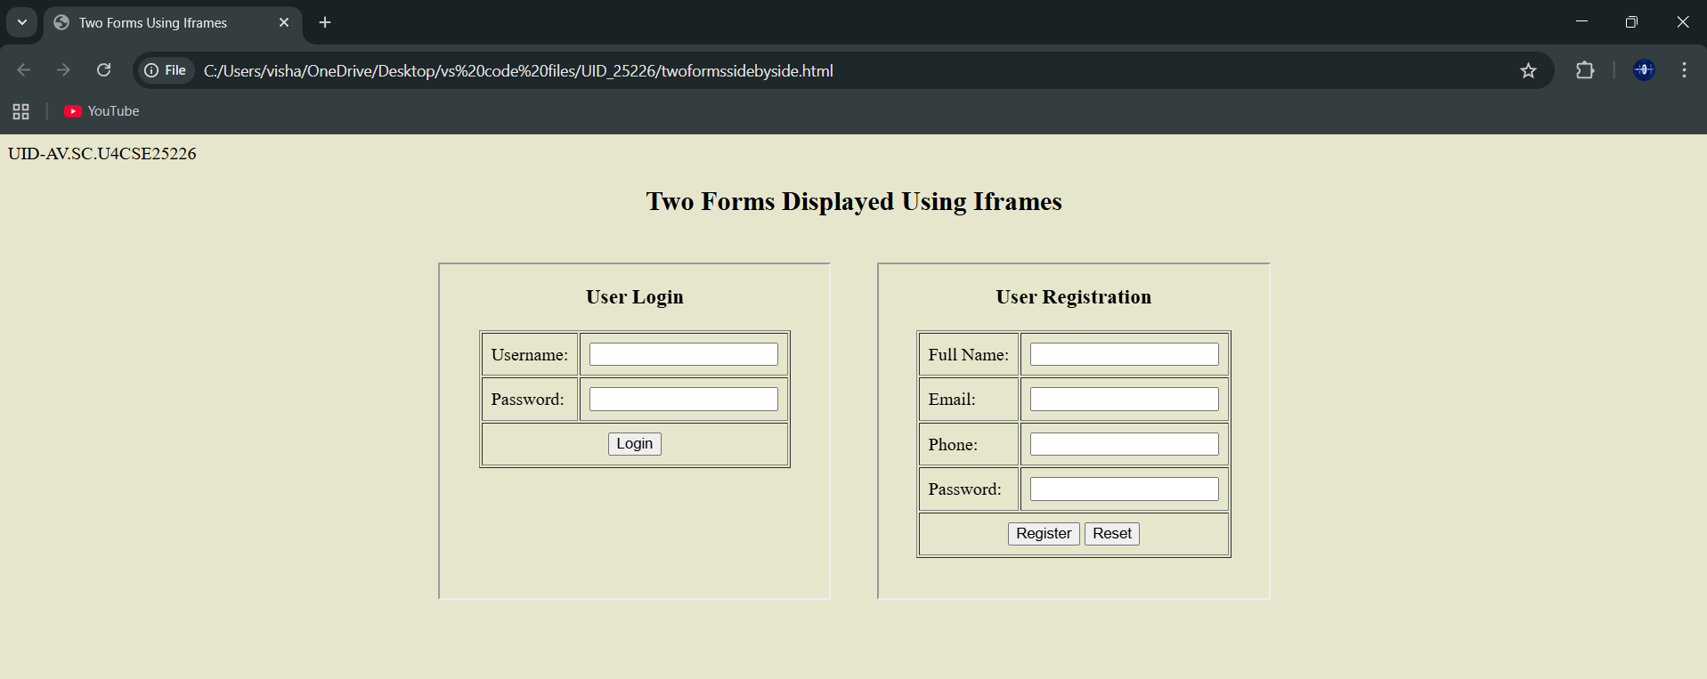
Explanation :
<DOCTYPE html> : the <!DOCTYPE html> element tells the web browser that this an HTML document
or this is the latest version of HTML
<html> : the <html> element is the root element of an HTML web page
<head> : the <head> element will contain meta data about the HTML web page
<title> : the <title> element specifies a title for the HTML Page
<body> : the <body> element contains all visible content all visible content like text , image , links ,
tables , etc
<h> : we used <h> element for heading
<p> : we used <p> element for the paragraph
<table>: the element <table> is used to create a table
<tr>: the element <tr> creates a new row in the table
<th>: the element <th> create a new heading inside the table
<td>: the element <td> fill the columns in the row
<label>:we used <label> element for linking the input to specific id name and we use for attribute for it
<input>:we use <input> element for the input elements in the forms
<select>:we use <select> element for creation of drop box
<option>:we use <option> element for creating the options in the drop box
<iframes>:we use <iframes> element for adding anoter html file to main html file
And we use style attribute for styling and designing the webpage and type for selecting the type of input that is going to In it and for and id tag is used to link the input to label and use the iframe for use the table and add two iframes in two boxes

Week-5:
5.A)Aim: creating a card layout using <div> tag consider three cards and a button using html and css
Program :
UID-AV.SC.U4CSE25226
<!DOCTYPE html>
<html>
<head>
<title>Marvel Super Heroes</title>
<style>
body{
font-family:Arial;
background:#0f172a;
text-align:center;
}
h1{
background:#b91c1c;
padding:20px;
}
.container{
display:flex;
flex-wrap:wrap;
justify-content:center;
gap:20px;
padding:30px;
}
.card{
background:white;
color:black;
width:260px;
padding:20px;
border-radius:12px;
box-shadow:0 5px 15px gray;
}
.hero-img{
width:150px;
height:200px;
object-fit:cover;
border-radius:8px;
}
button{
padding:8px 16px;
border:none;
background:#b91c1c;
color:white;
border-radius:6px;
}
button:hover{
background:black;
}
</style>
</head>
<body>
<h1>Marvel Super Heroes</h1>
<div class="container">
<div class="card">
<img class="hero-img"
src="C:\Users\visha\OneDrive\Pictures\Screenshots\cap.jpg">
<h3>Captain America</h3>
<p>Winter Soldier</p>
<button>Know More</button>
</div>
<div class="card">
<img class="hero-img"
src="C:\Users\visha\OneDrive\Pictures\Screenshots\iron.jpg">
<h3>Iron Man</h3>
<p>Tony Stark</p>
<button>Know More</button>
</div>
<div class="card">
<img class="hero-img"
src="C:\Users\visha\OneDrive\Pictures\Screenshots\thor.jpg">
<h3>Thor</h3>
<p>Odinson</p>
<button>Know More</button>
</div>
</div>
</body>
</html>
Output :
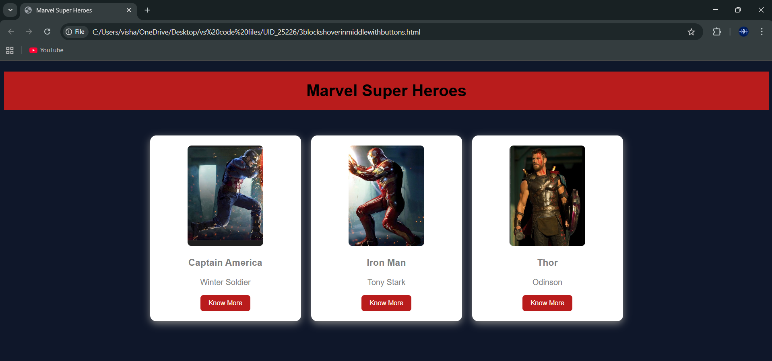
Explanation :
<DOCTYPE html> : the <!DOCTYPE html> element tells the web browser that this an HTML document
or this is the latest version of HTML
<html> : the <html> element is the root element of an HTML web page
<head> : the <head> element will contain meta data about the HTML web page
<title> : the <title> element specifies a title for the HTML Page
<body> : the <body> element contains all visible content all visible content like text , image , links ,
tables , etc
<h> : we used <h> element for heading
<p> : we used <p> element for the paragraph
<div>:we use <div> element for encapsulating the the divisions and easy to modify and
<button>: we use <button> element for button
<img>: we use <img> tag for displaying the image
And we internal css for the html page and use element and class selector to apply the css to the div elements and src attribute for image path ,by using the class and internal css we created this webpage

5.B)Aim: Navigation using iframe (mini website) upon clicking each buttons the details about that
button should be display on the same page
program:
ironmain.html:(main)
UID-AV.SC.U4CSE25226
<!DOCTYPE html>
<html>
<head>
<title>Iron Man</title>
<style>
body{margin:0;font-family:Arial;background-color: gray;}
.menu{
background:#b91c1c;
padding:15px;
text-align:center;
}
.menu a{
color:white;
margin:0 15px;
text-decoration:none;
background:black;
padding:8px 12px;
}
iframe{
width:100%;
height:400px;
border:none;
}
</style>
</head>
<body>
<h1 style="text-align:center;background:#b91c1c;color:white;padding:20px;">Iron Man</h1>
<div class="menu">
<a href="strengths.html" target="frame">Strengths & Weaknesses</a>
<a href="personal.html" target="frame">Personal Info</a>
<a href="contribution.html" target="frame">Contributions</a>
</div>
<iframe name="frame"></iframe>
</body>
</html>
Strengths.html(sub)
UID-AV.SC.U4CSE25226
<!DOCTYPE html>
<html>
<head>
<style>
body{font-family:Arial;text-align:center;}
.box{
border:2px solid black;
padding:20px;
display:inline-block;}
h2{color:#b91c1c;}
</style>
</head>
<body>
<div class="box">
<h2>Strengths and Weaknesses</h2>
<p>Strengths: Genius mind, powerful armor.</p>
<p>Weaknesses: Ego, suit dependency.</p>
<img src="C:\Users\visha\OneDrive\Pictures\Screenshots\iron31.png" alt="Iron Man" style="width:200px;height:200px;">
</div>
</body>
</html>
Personal.html:(sub)
UID-AV.SC.U4CSE25226
<!DOCTYPE html>
<html>
<head>
<style>
body{font-family:Arial;text-align:center}
.box{
border:2px solid black;
padding:20px;
display:inline-block;}
h2{color:#b91c1c;}
</style>
</head>
<body>
<div class="box">
<h2>Personal Information</h2>
<p>Name: Tony Stark</p>
<p>Company: Stark Industries</p>
<p>Team: Avengers</p>
<img src="C:\Users\visha\OneDrive\Pictures\Screenshots\iron32.png" alt="Tony Stark" style="width:200px;margin-top:20px;">
</div>
</html>
Contribution.html:(sub)
UID-AV.SC.U4CSE25226
<!DOCTYPE html>
<html>
<head>
<style>
body{font-family:Arial;text-align:center}
.box{
border:2px solid black;
padding:20px;
display:inline-block;}
h2{color:#b91c1c;}
</style>
</head>
<body>
<div class="box">
<h2>Contributions</h2>
<p>Built Iron Man suits.</p>
<p>Helped defeat Thanos.</p>
<p>Saved Earth many times.</p>
<img src="C:\Users\visha\OneDrive\Pictures\Screenshots\iron33.png" alt="Iron Man" style="width:200px;margin-top:20px;">
</div>
</body>
</html>
Output :
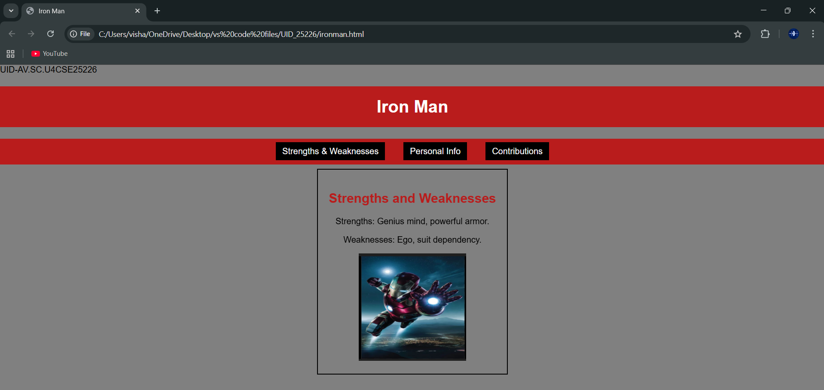
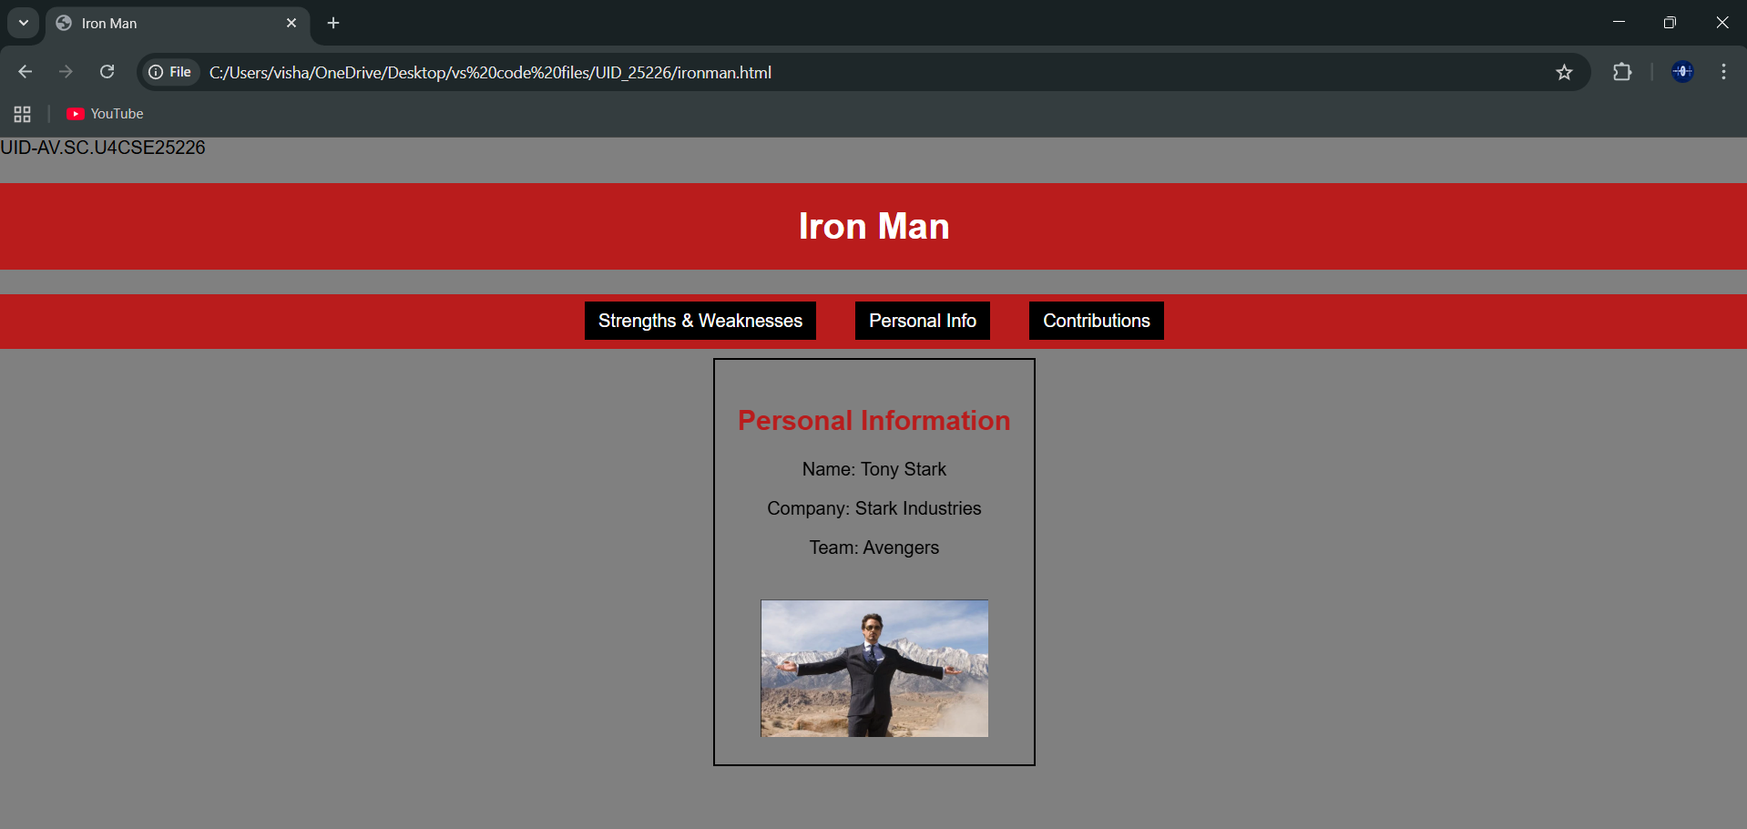
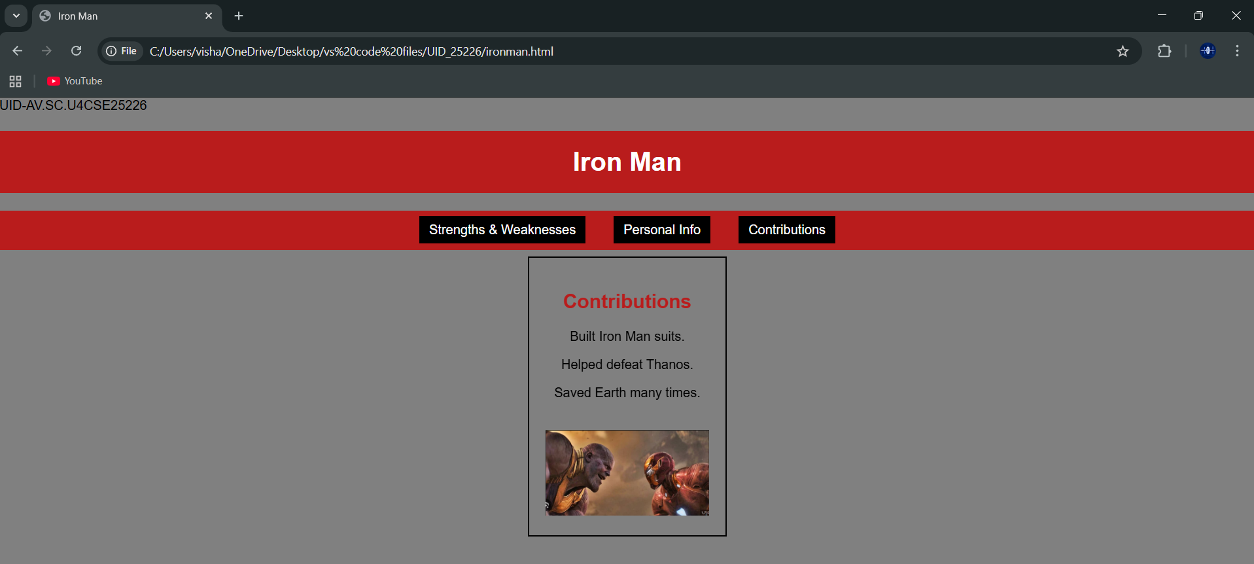
Explanation :
<DOCTYPE html> : the <!DOCTYPE html> element tells the web browser that this an HTML document
or this is the latest version of HTML
<html> : the <html> element is the root element of an HTML web page
<head> : the <head> element will contain meta data about the HTML web page
<title> : the <title> element specifies a title for the HTML Page
<body> : the <body> element contains all visible content all visible content like text , image , links ,
tables , etc
<h> : we used <h> element for heading
<p> : we used <p> element for the paragraph
<div>:we use <div> element for encapsulating the the divisions and easy to modify and
<button>: we use <button> element for button
<img>: we use <img> tag for displaying the image
And we internal css for the html page and use element and class selector to apply the css to the div elements and src attribute for image path ,by using the class and internal css we created this webpage and href attribute is used to link the html pages to the main webpage and use target attribute to link the anchor element to href attribute . and the three webpages are linked to main webpage .and inline attribute for the boder to wrap around it .

5.c)Aim: Design amrita login page by showcampus on home page.upon clicking on each campus
the details about each campus should be display on the same page use html and css to
design a stylish webpage
program:
Main file:
AV.SC.U4CSE25226-UID
<!DOCTYPE html>
<html>
<head>
<title>Amrita Vishwa Vidhyapeetam</title>
<style>
body{margin:0;font-family:Arial;background:rgb(101, 101, 139);}
header{background:#a00000;color:#fff;text-align:center;
padding:20px;font-size:36px;}
nav{background:#0b5ea6;text-align:center;padding:10px;}
nav a{color:yellow;margin:12px;text-decoration:none;
font-weight:bold;padding:5px;}
nav a:hover{background:#fff;color:#0b5ea6;
border-radius:5px;}
main{display:flex;padding:20px;}
.login{
width:350px;
background:#2ecc71;
padding:15px;
border-radius:10px;
color:white;
}
.login input[type="email"],
.login input[type="password"]{
width:90%;
padding:6px;
margin:6px 0;
}
.remember{display:flex;align-items:center;gap:6px;margin:8px 0;}
iframe{
flex:1;
margin-left:20px;
height:520px;
border:none;
background:lightskyblue;
border-radius:10px;
}
</style>
</head>
<body>
<header>AMRITA VISHWA VIDHYAPEETAM</header>
<nav>
<a href="amaravati.html" target="campus">AMARAVATI</a>
<a href="amritapuri.html" target="campus">AMRITAPURI</a>
<a href="bengaluru.html" target="campus">BENGALURU</a>
<a href="chennai.html" target="campus">CHENNAI</a>
<a href="coimbatore.html" target="campus">COIMBATORE</a>
<a href="faridabad.html" target="campus">FARIDABAD</a>
<a href="kochi.html" target="campus">KOCHI</a>
<a href="mysuru.html" target="campus">MYSURU</a>
</nav>
<main>
<div class="login">
<h2>Login</h2>
Email
<input type="email">
Password
<input type="password">
<div class="remember">
<input type="checkbox"><label>Save me</label>
</div>
<input type="button" value="Login" style="width:100%;padding:6px;">
<br><br>
<a href="#">Forgot Password?</a><br>
No account? <a href="#">Register</a>
</div>
<iframe name="campus" src="amaravati.html"></iframe>
</main>
</body>
</html>
Amaravathi:
<!DOCTYPE html>
<html>
<body style="font-family:Arial; text-align:center; padding:30px;">
<h1 style="color:#a00000;">Amaravati Campus</h1>
<p>
Amrita Amaravati campus is located near the Krishna River in Andhra Pradesh.
It provides modern classrooms, research labs, and excellent hostel facilities.
</p>
<p>
Popular Courses: CSE, AI, Data Science<br>
Facilities: Library, Smart Classrooms, Hostel<br>
Focus: Innovation and Research
</p>
<img src="C:\Users\visha\OneDrive\Pictures\Screenshots\amaravathi.png" width="450">
</body>
</html>
Bengluru:
<!DOCTYPE html>
<html>
<body style="font-family:Arial;text-align:center;padding:30px;">
<h1 style="color:#a00000;">Bengaluru Campus</h1>
<p>
Located in India's tech hub, Bengaluru campus offers advanced
engineering programs with strong industry connections.
</p>
<p>
Popular Courses: Robotics, CSE, ECE<br>
Facilities: Coding Labs, Innovation Centres<br>
Focus: Industry Collaboration
</p>
<img src="C:\Users\visha\OneDrive\Pictures\Screenshots\benguluru.png" width="450">
</body>
</html>
Amritapuri:
<!DOCTYPE html>
<html>
<body style="font-family:Arial;text-align:center;padding:30px;">
<h1 style="color:#a00000;">Amritapuri Campus</h1>
<p>
Amritapuri campus in Kerala is the main campus of Amrita University,
located near the Arabian Sea with a peaceful academic atmosphere.
</p>
<p>
Popular Courses: Engineering, Arts, Sciences<br>
Facilities: Research Labs, Beach Campus, Hostel<br>
Focus: Academic Excellence with Values
</p>
<img src="C:\Users\visha\OneDrive\Pictures\Screenshots\amritapuri.png" width="450">
</body>
</html>
Chennai:
<!DOCTYPE html>
<html>
<body style="font-family:Arial;text-align:center;padding:30px;">
<h1 style="color:#a00000;">Chennai Campus</h1>
<p>
Chennai campus provides top-quality computing and management education
with modern infrastructure and placement support.
</p>
<p>
Popular Courses: IT, MBA, Electronics<br>
Facilities: Digital Library, Placement Cell<br>
Focus: Career Development
</p>
<img src="C:\Users\visha\OneDrive\Pictures\Screenshots\chennai.png" width="450">
</body>
</html>
Coiambatore:
<!DOCTYPE html>
<html>
<body style="font-family:Arial;text-align:center;padding:30px;">
<h1 style="color:#a00000;">Coimbatore Campus</h1>
<p>
Coimbatore campus is well known for its engineering excellence
and research-oriented education.
</p>
<p>
Popular Courses: Mechanical, Civil, CSE<br>
Facilities: Workshops, Labs, Hostel<br>
Focus: Core Engineering Skills
</p>
<img src="C:\Users\visha\OneDrive\Pictures\Screenshots\coimbatore.png" width="450">
</body>
</html>
Faridabadh:
<!DOCTYPE html>
<html>
<body style="font-family:Arial;text-align:center;padding:30px;">
<h1 style="color:#a00000;">Faridabad Campus</h1>
<p>
Faridabad campus focuses on medical and healthcare education
with advanced hospital training facilities.
</p>
<p>
Popular Courses: Medical, Nursing, Allied Health<br>
Facilities: Teaching Hospital, Labs<br>
Focus: Healthcare Research
</p>
<img src="C:\Users\visha\OneDrive\Pictures\Screenshots\faridabadh.png" width="450">
</body>
</html>
Kochi:
<!DOCTYPE html>
<html>
<body style="font-family:Arial;text-align:center;padding:30px;">
<h1 style="color:#a00000;">Kochi Campus</h1>
<p>
Kochi campus offers programs in business, commerce,
and applied sciences with modern facilities.
</p>
<p>
Popular Courses: MBA, Commerce, Finance<br>
Facilities: Seminar Halls, Library<br>
Focus: Industry Training
</p>
<img src="C:\Users\visha\OneDrive\Pictures\Screenshots\kochi.png" width="450">
</body>
</html>
Mysore:
<!DOCTYPE html>
<html>
<body style="font-family:Arial;text-align:center;padding:30px;">
<h1 style="color:#a00000;">Mysuru Campus</h1>
<p>
Mysuru campus is known for its peaceful environment,
green campus, and quality education.
</p>
<p>
Popular Courses: Arts, Sciences, Engineering<br>
Facilities: Hostel, Library, Sports Complex<br>
Focus: Calm Learning Atmosphere
</p>
<img src="C:\Users\visha\OneDrive\Pictures\Screenshots\mysur.png" width="450">
</body>
</html>
Outout:
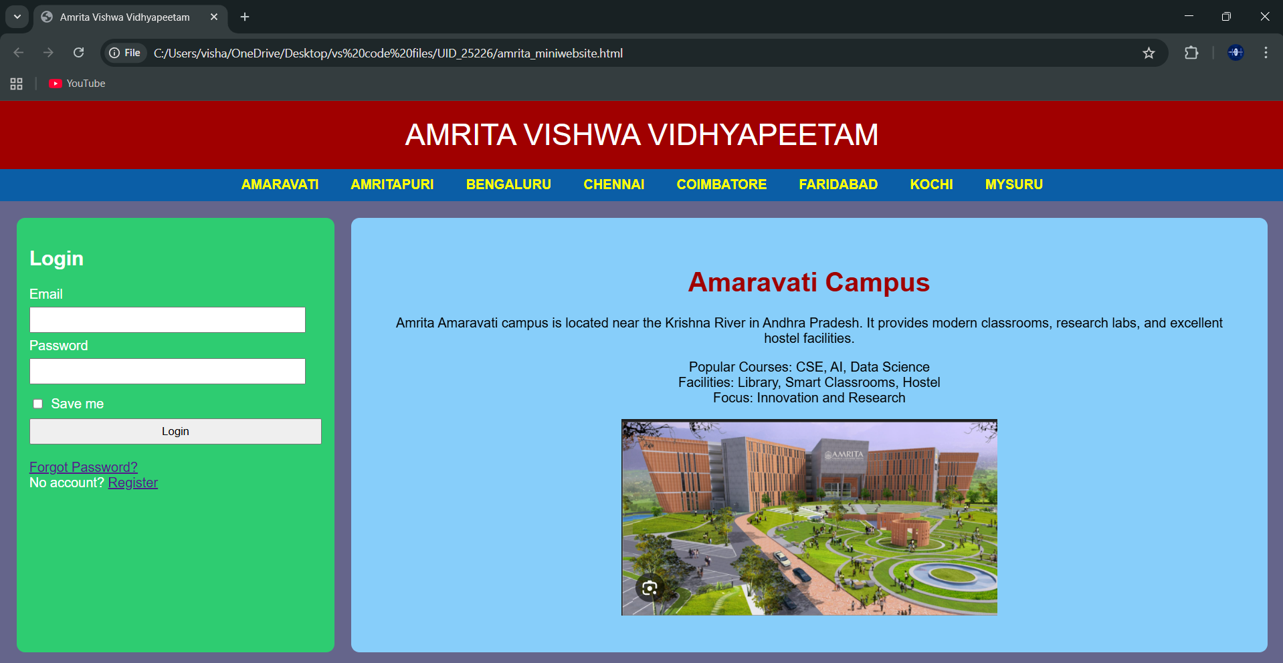
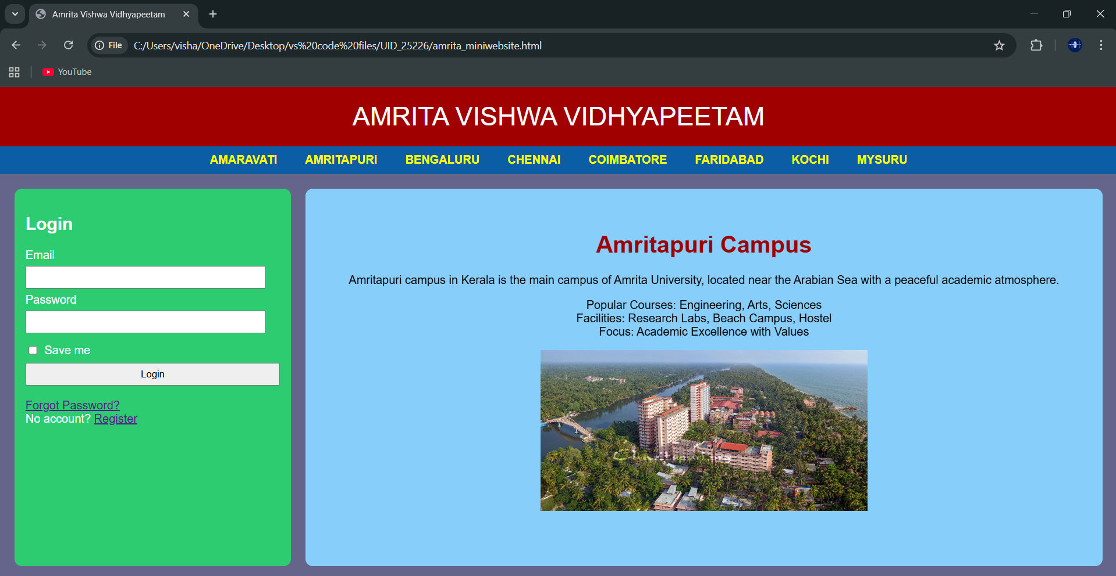
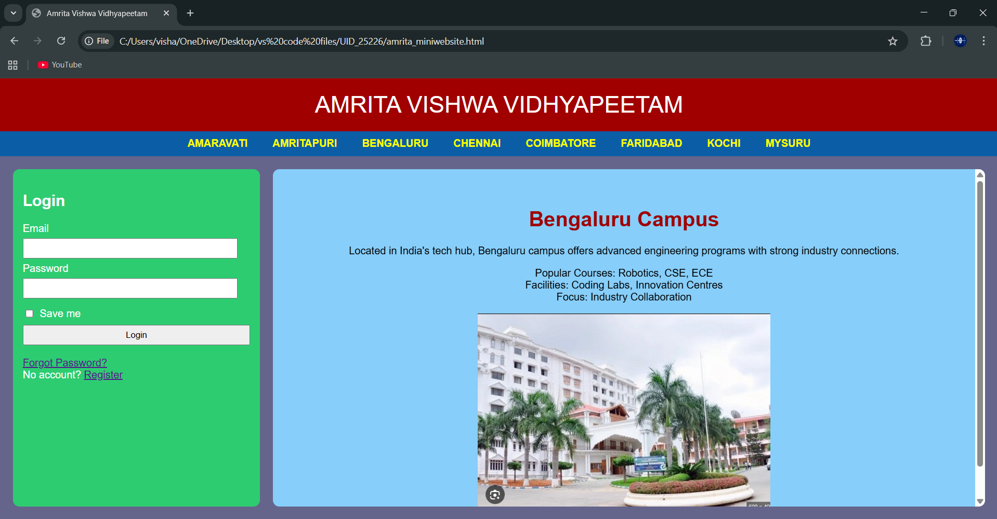
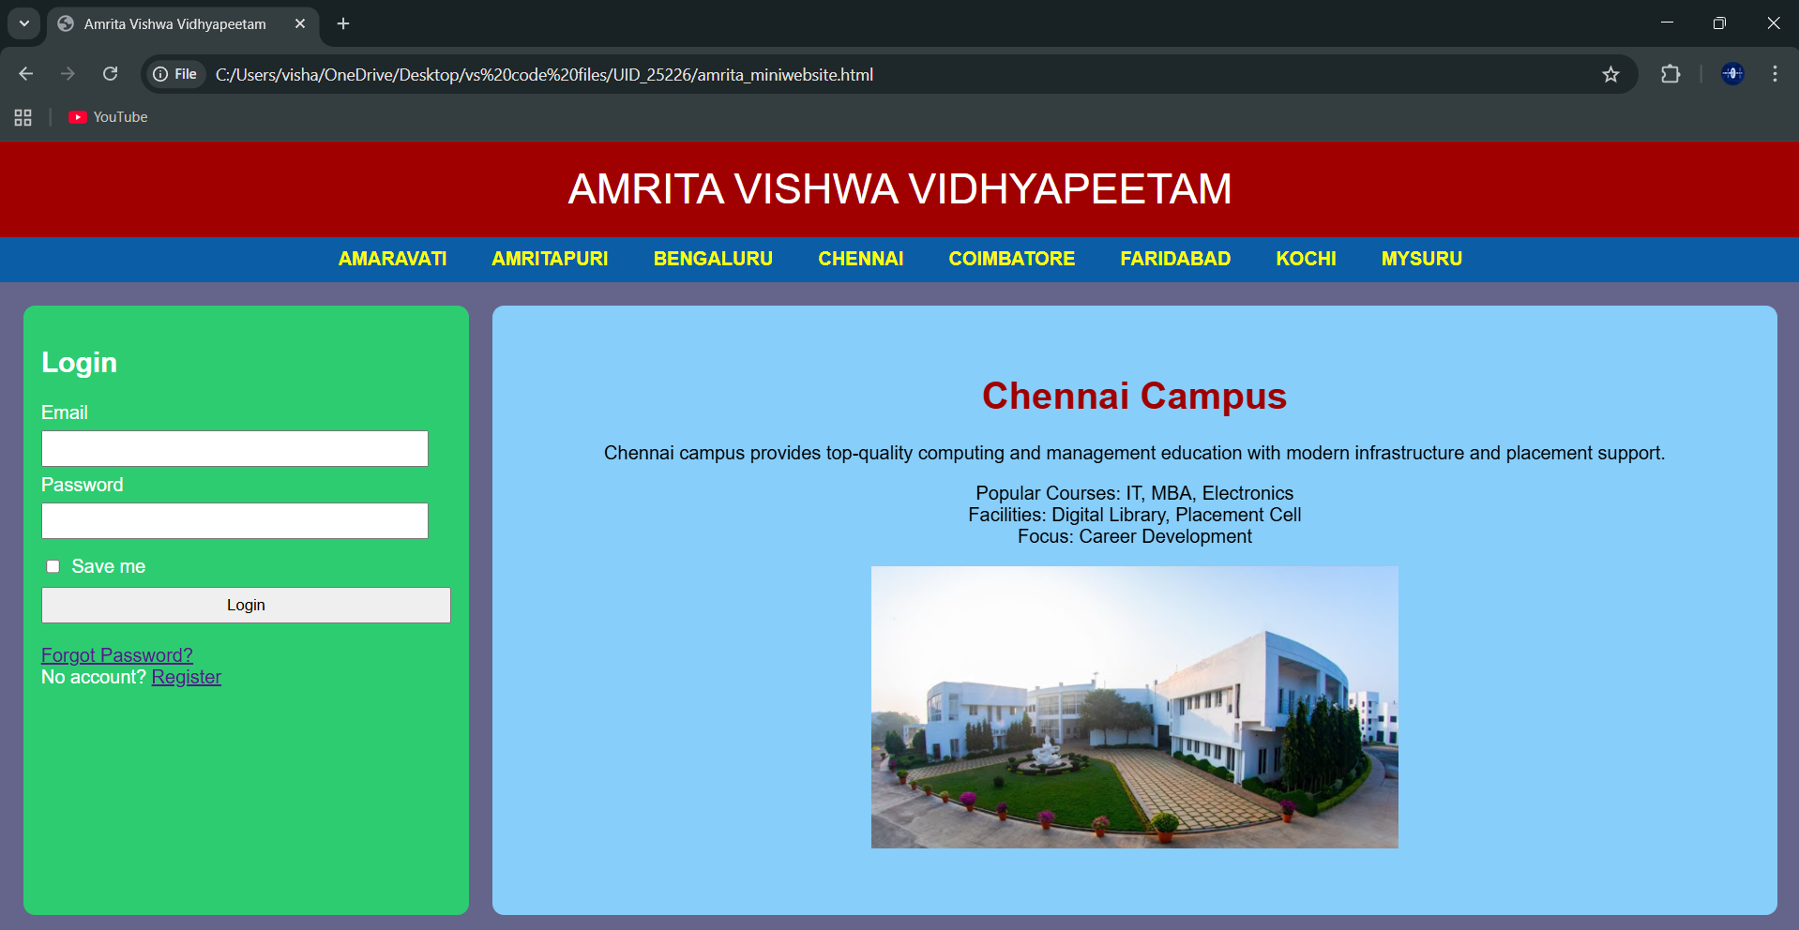
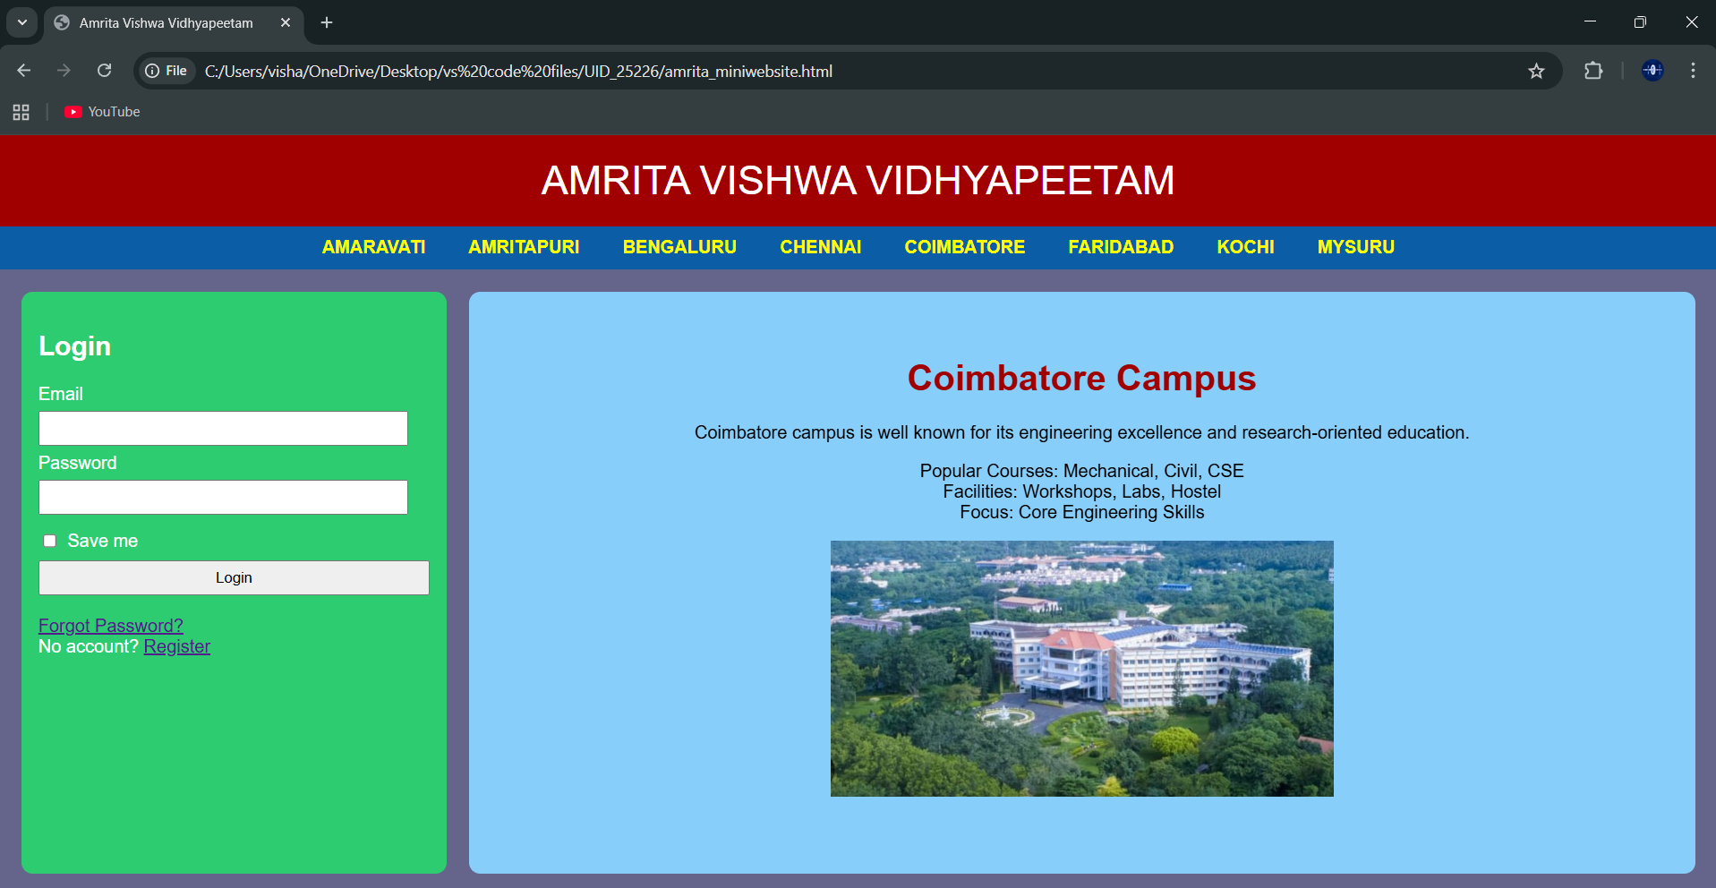
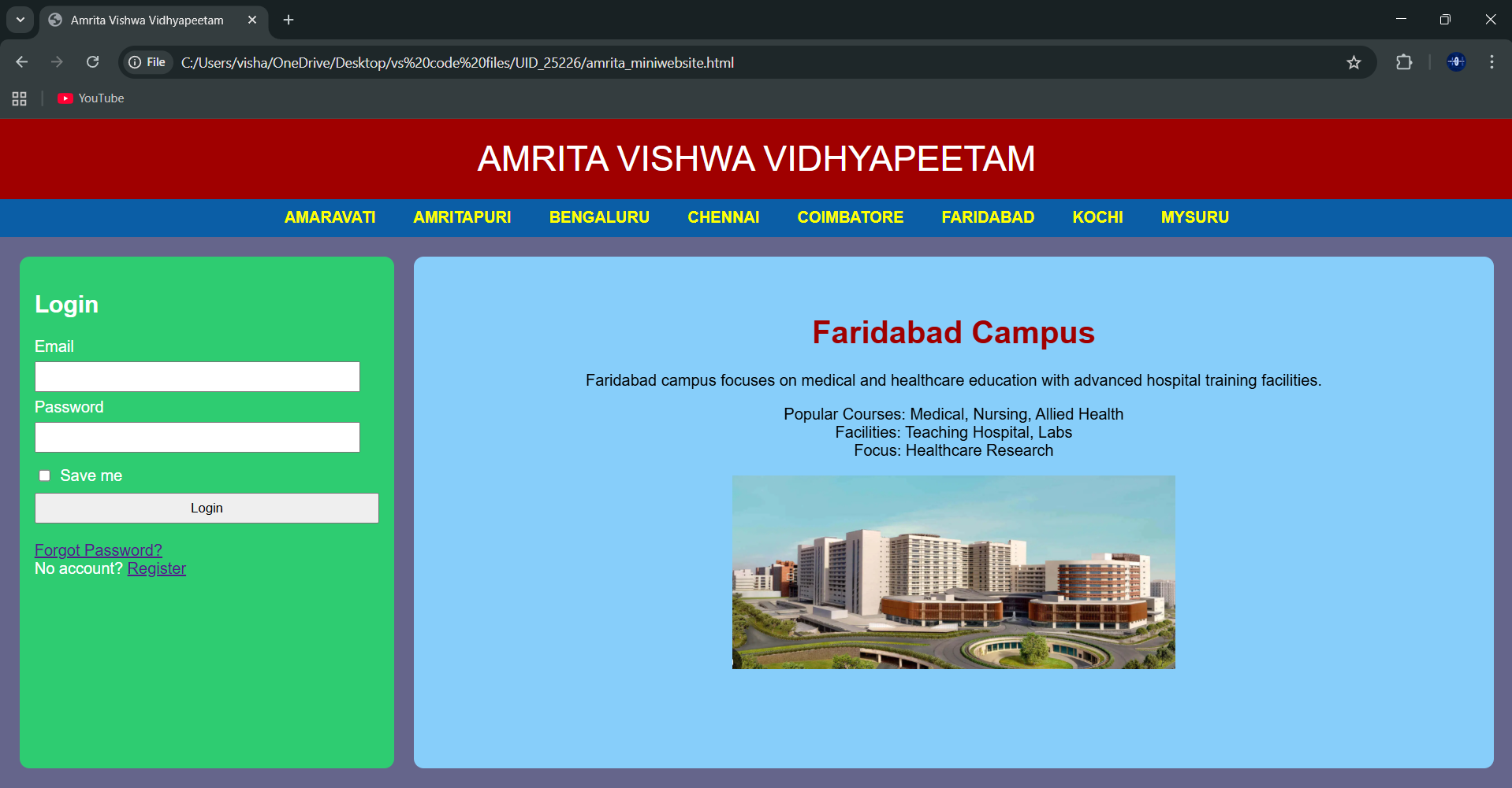
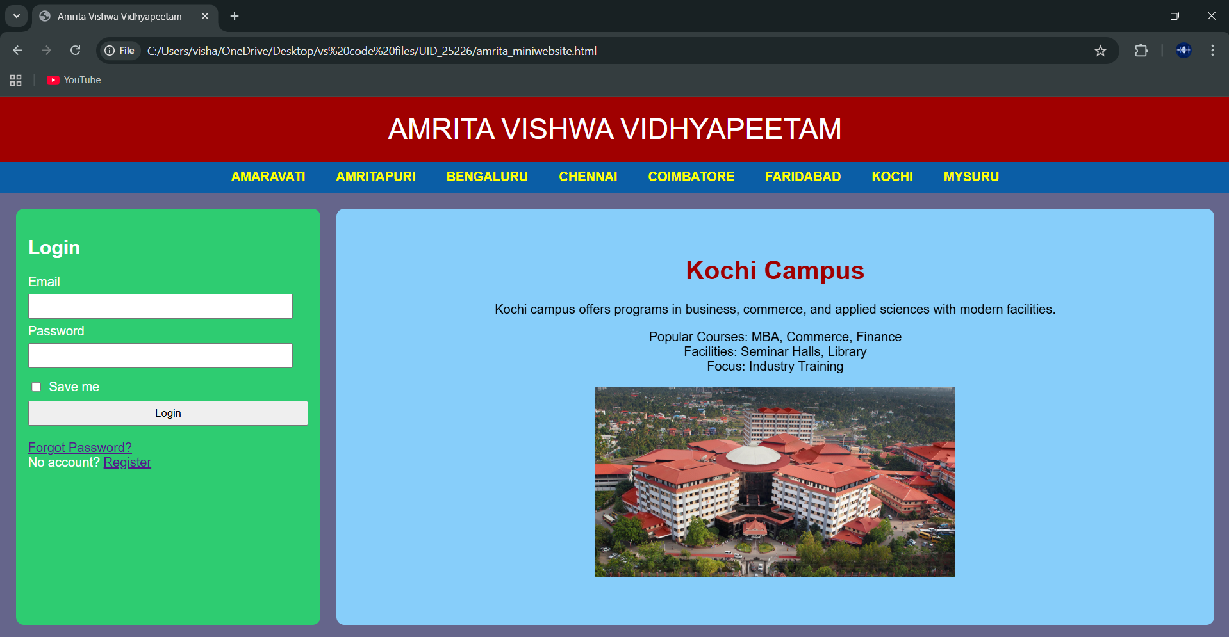
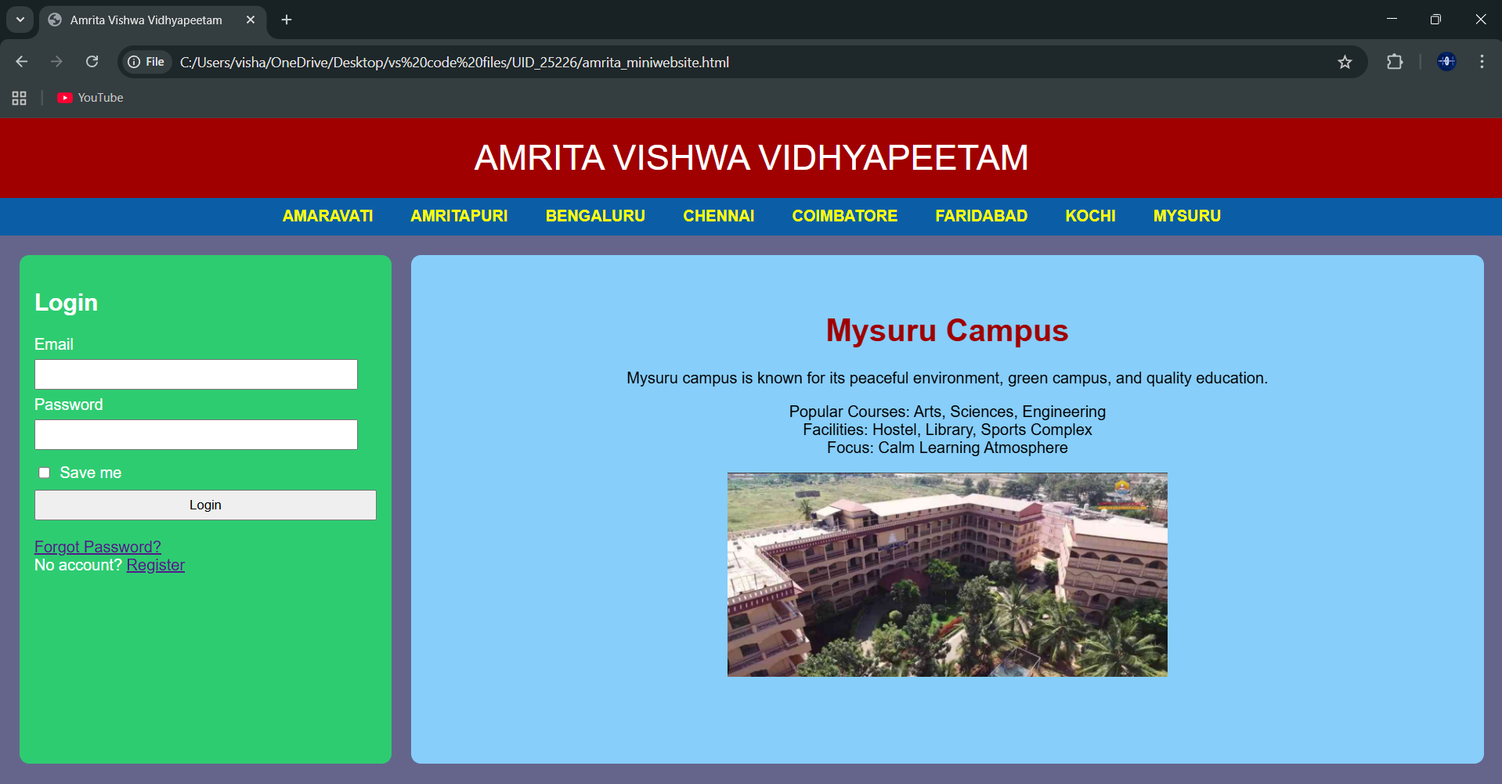
Explanation :
<DOCTYPE html> : the <!DOCTYPE html> element tells the web browser that this an HTML document
or this is the latest version of HTML
<html> : the <html> element is the root element of an HTML web page
<head> : the <head> element will contain meta data about the HTML web page
<title> : the <title> element specifies a title for the HTML Page
<body> : the <body> element contains all visible content all visible content like text , image , links ,
tables , etc
<h> : we used <h> element for heading
<p> : we used <p> element for the paragraph
<div>:we use <div> element for encapsulating the the divisions and easy to modify and
<button>: we use <button> element for button
<img>: we use <img> tag for displaying the image
<Iframes>:we use <iframe> element for creating the login block that stays left to it
We used different types of input attributes for different inputs
And we internal css for the html page and use element and class selector to apply the css to the div elements and src attribute for image path ,by using the class and internal css we created this webpage and href attribute is used to link the html pages to the main webpage and use target attribute to link the anchor element to href attribute . and the three webpages are linked to main webpage .and inline attribute for the boder to wrap around it .
We used iframes and target attributes to link the iframes to the webpage and the all the required I frame attributes are used in it and
Week-6:
6.A) Aim: Design a responsive e-commerce application using the grid layout. This application should contain different categories of products such as electronics, clothing, home-appliances, books.
Program :
AV.SC.U4CSE25226-UID
<!DOCTYPE html>
<html>
<head>
<title>My E-commerce Website</title>
<style>
body{
font-family: Arial, sans-serif;
margin: 0;
padding: 0;
background-color: black;
}
.container{
display: grid;
grid-template-rows: auto auto 1fr auto;
grid-template-columns: 200px 1fr;
grid-template-areas:
"header header"
"sale sale"
"sidebar main"
"footer footer";
gap: 10px;
padding: 10px;
}
.header{
grid-area: header;
background-color:gray ;
padding: 10px;
text-align: center;
}
.sale{
grid-area: sale;
background-color: gray;
padding: 10px;
text-align: center;
}
.sidebar{
grid-area: sidebar;
background-color: gray;
padding: 10px;
}
.main{
grid-area: main;
background-color: gray;
padding: 10px;
display: grid;
grid-template-columns: repeat(2, 1fr);
gap: 10px;
}
.footer{
grid-area: footer;
background-color: gray;
padding: 10px;
text-align: center;
}
.product{
background-color:lightgray;
padding: 10px;
border-radius: 5px;
text-align: center;
}
.product-image{
width: 200px;
height: 200px;
}
.button{
background-color: grey;
color: black;
border: 2px solid white;
padding: 10px 20px;
border-radius: 5px;
}
.button:hover{
background-color: lightslategray;
color: black;
border: 2px solid black;
}
</style>
</head>
<body>
<div class="container">
<div class="header">
<h1>TOYS 4 TOYS</h1>
</div>
<div class="sale">
<p>Special Sale!</p>
</div>
<div class="sidebar">
<h2>Categories</h2>
<ul>
<li>RC CARS</li>
<li>LEGOS</li>
<li>HAPTIC TOYS</li>
<li>BOARD GAMES</li>
</ul>
</div>
<div class="main">
<div class="product">
<img class="product-image" src="C:\Users\visha\OneDrive\Pictures\Screenshots\rc car.webp" alt="RC Car">
<h3>RC Car</h3>
<p>Price: $29.99</p>
<button class="button">Add to Cart</button>
</div>
<div class="product">
<img class="product-image" src="C:\Users\visha\OneDrive\Pictures\Screenshots\lego.jpg" alt="LEGO Set">
<h3>LEGO Set</h3>
<p>Price: $49.99</p>
<button class="button">Add to Cart</button>
</div>
<div class="product">
<img class="product-image" src="C:\Users\visha\OneDrive\Pictures\Screenshots\haptic.jpg" alt="Haptic Toy">
<h3>Haptic Toy</h3>
<p>Price: $19.99</p>
<button class="button">Add to Cart</button>
</div>
<div class="product">
<img class="product-image" src="C:\Users\visha\OneDrive\Pictures\Screenshots\monopoly.jpg" alt="Board Game">
<h3>Board Game</h3>
<p>Price: $39.99</p>
<button class="button">Add to Cart</button>
</div>
</div>
<div class="footer">
<p>&copy; copyright TOYS 4 TOYS Website. All rights reserved.</p>
</div>
</div>
</body>
</html>
Output:
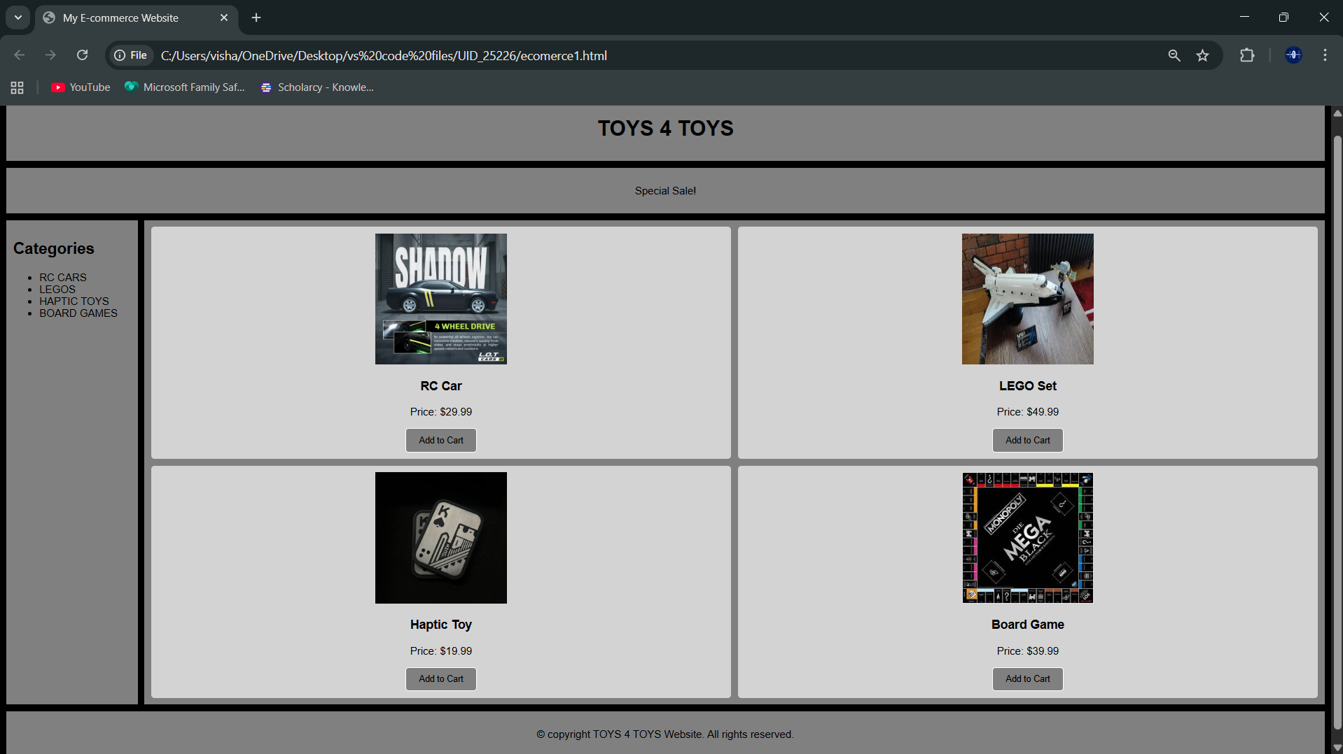
Explanation:
<DOCTYPE html> : the <!DOCTYPE html> element tells the web browser that this an HTML document
or this is the latest version of HTML
<html> : the <html> element is the root element of an HTML web page
<head> : the <head> element will contain meta data about the HTML web page
<title> : the <title> element specifies a title for the HTML Page
<body> : the <body> element contains all visible content all visible content like text , image , links ,
tables , etc
<h> : we used <h> element for heading
<p> : we used <p> element for the paragraph
<div>:we use <div> element for encapsulating the the divisions and easy to modify and
<button>: we use <button> element for button
<img>: we use <img> tag for displaying the image
We used layout in this program and its attributes like grid-template-rows, grid-template-coloums, grid-template-area to define the items space for the grid layout by dividing page into separate sections and use div tag make into small separate blocks
6.B) Aim: Design a responsive e-commerce application using the grid layout. This application should contain different categories of products such as electronics, clothing, home-appliances, books. Based on the category we select corresponding products should be displayed on the sidebar.
Program:
Main:
AV.SC.U4CSE25226-UID
<!DOCTYPE html>
<html>
<head>
<title>TOYS 4 TOYS</title>
<style>
body{
margin:0;
font-family:Arial;
color:#fff;
background:url("backgroundimages.jpg") center/cover fixed no-repeat;
}
body::before{
content:"";
position:fixed;
inset:0;
background:rgba(0,0,0,.75);
z-index:-1;
}
.container{
display:grid;
grid-template:
"header header" auto
"sale sale" auto
"sidebar main" 1fr
"footer footer" auto /220px 1fr;
gap:15px;
padding:15px;
}
.header,.sale,.sidebar,.main,.footer{
background:rgba(40,40,40,.65);
border-radius:12px;
padding:15px;
box-shadow:0 0 15px #000;
}
.header{grid-area:header;text-align:center;font-size:28px;letter-spacing:3px;}
.sale{grid-area:sale;overflow:hidden;white-space:nowrap;height:40px;position:relative;}
.sale p{
position:absolute;
color:#00ffd5;
font-size:20px;
animation:move 10s linear infinite;
}
@keyframes move{
from{left:-100%;}
to{left:100%;}
}
.sidebar{grid-area:sidebar}
.sidebar ul{list-style:none;padding:0}
.sidebar li{margin:15px 0}
.sidebar a{
color:#fff;
text-decoration:none;
font-size:18px;
transition:.3s;
}
.sidebar a:hover{color:#00ffd5;padding-left:8px}
.main{grid-area:main}
iframe{width:100%;height:520px;border:0;background:rgba(0,0,0,.5);border-radius:10px}
.footer{grid-area:footer;text-align:center;font-size:14px;opacity:.85}
</style>
</head>
<body>
<div class="container">
<div class="header">TOYS 4 TOYS</div>
<div class="sale">
<p>🔥 SPECIAL SALE – UP TO 50% OFF ON ALL TOYS 🔥</p>
</div>
<div class="sidebar">
<h2>Categories</h2>
<ul>
<li><a href="rc-cars.html" target="contentFrame">RC CARS</a></li>
<li><a href="legos.html" target="contentFrame">LEGOS</a></li>
<li><a href="haptic-toys.html" target="contentFrame">HAPTIC TOYS</a></li>
<li><a href="board-games.html" target="contentFrame">BOARD GAMES</a></li>
</ul>
</div>
<div class="main">
<iframe name="contentFrame"></iframe>
</div>
<div class="footer">
© TOYS 4 TOYS Website
</div>
</div>
</body>
</html>
Sub1:
<!DOCTYPE html>
<html>
<head>
<title>RC Cars</title>
<style>
body{
font-family: Arial, sans-serif;
margin:0;
padding:20px;
background-color: gray;
}
.container{
display:grid;
grid-template-columns: 1fr 1fr; /* 2 columns */
grid-template-rows: auto auto; /* 2 rows */
gap:20px;
}
.card{
background:white;
padding:20px;
border-radius:10px;
box-shadow:0 4px 10px rgba(0,0,0,0.2);
text-align:center;
}
.card-img{
width:200px;
height:200px;
border-radius:10px;
margin-bottom:10px;
}
.price{
font-size:18px;
color:green;
margin-top:10px;
}
</style>
</head>
<body>
<div class="container">
<div class="card">
<img class="card-img" src="C:\Users\visha\OneDrive\Pictures\Screenshots\flare.jpg" alt="RC Car 1">
<h2>FLARE</h2>
<p>High speed remote control car.</p>
<p class="price">$29.99</p>
</div>
<div class="card">
<img class="card-img" src="C:\Users\visha\OneDrive\Pictures\Screenshots\dash.jpg" alt="RC Car 2">
<h2>DASH</h2>
<p>Mini remote control car.</p>
<p class="price">$34.99</p>
</div>
<div class="card">
<img class="card-img" src="C:\Users\visha\OneDrive\Pictures\Screenshots\ghost.jpg" alt="RC Car 3">
<h2>GHOST</h2>
<p>Drift racing car model.</p>
<p class="price">$39.99</p>
</div>
<div class="card">
<img class="card-img" src="C:\Users\visha\OneDrive\Pictures\Screenshots\rc car.webp" alt="RC Car 4">
<h2>SHADOW</h2>
<p>RC drift car</p>
<p class="price">$44.99</p>
</div>
</div>
</body>
</html>
Sub2:
<!DOCTYPE html>
<html>
<head>
<title>LEGO Toys</title>
<style>
body{
font-family: Arial, sans-serif;
margin:0;
padding:20px;
background-color: gray;
}
.container{
display:grid;
grid-template-columns: 1fr 1fr; /* 2 columns */
grid-template-rows: auto auto; /* 2 rows */
gap:20px;
}
.card{
background:white;
padding:20px;
border-radius:10px;
box-shadow:0 4px 10px rgba(0,0,0,0.2);
text-align:center;
}
.card-img{
width:200px;
height:200px;
border-radius:10px;
margin-bottom:10px;
}
.price{
font-size:18px;
color:green;
margin-top:10px;
}
</style>
</head>
<body>
<div class="container">
<div class="card">
<img src="C:\Users\visha\OneDrive\Pictures\Screenshots\lego.jpg" alt="lego" class="card-img">
<h2>LEGO SHUTTEL</h2>
<p>space shuttel</p>
<p class="price">$19.99</p>
</div>
<div class="card">
<img src="C:\Users\visha\OneDrive\Pictures\Screenshots\lego3.jpg" alt="lego space" class="card-img">
<h2>TAJ MAHAL</h2>
<p>beautiful indian architecture</p>
<p class="price">$24.99</p>
</div>
<div class="card">
<img src="C:\Users\visha\OneDrive\Pictures\Screenshots\lego4.jpg" alt="lego police" class="card-img">
<h2>colloseum</h2>
<p>ancient roman amphitheater</p>
<p class="price">$29.99</p>
</div>
<div class="card">
<img src="C:\Users\visha\OneDrive\Pictures\Screenshots\lego marvel.avif" alt="lego racing" class="card-img">
<h2>LEGO STARK TOWER</h2>
<p>Build a towering LEGO structure.</p>
<p class="price">$34.99</p>
</div>
</div>
</body>
</html>
Sub3:
<!DOCTYPE html>
<html>
<head>
<title>Haptic Toys</title>
<style>
body{
font-family: Arial, sans-serif;
margin:0;
padding:20px;
background-color: gray;
}
.container{
display:grid;
grid-template-columns: 1fr 1fr;
gap:20px;
}
.card{
background:white;
padding:20px;
border-radius:10px;
box-shadow:0 4px 10px rgba(0,0,0,0.2);
text-align:center;
}
.card-image{
width:200px;
height:200px;
border-radius:10px;
margin-bottom:10px;
}
.price{
font-size:18px;
color:green;
margin-top:10px;
}
</style>
</head>
<body>
<div class="container">
<div class="card">
<img src="C:\Users\visha\OneDrive\Pictures\Screenshots\haptic.jpg" alt="haptic" class="card-image">
<h2>LAUTTIE SHUFFEL</h2>
<p>Fun magnetic slider toy for stress relief.</p>
<p class="price">$9.99</p>
</div>
<div class="card">
<img src="C:\Users\visha\OneDrive\Pictures\Screenshots\shuffel2.jpg" alt="haptic fidget" class="card-image">
<h2>LAUTTIE SHUFFEL 2</h2>
<p>Fun magnetic slider toy for stress relief.</p>
<p class="price">$14.99</p>
</div>
<div class="card">
<img src="C:\Users\visha\OneDrive\Pictures\Screenshots\shuffel3.jpg" alt="haptic sensory" class="card-image">
<h2>SPINNER</h2>
<p>casino style spinner</p>
<p class="price">$19.99</p>
</div>
<div class="card">
<img src="C:\Users\visha\OneDrive\Pictures\Screenshots\shuffel4.jpg" alt="haptic spinner" class="card-image">
<h2>HAPTIC COIN</h2>
<p>haptic magnetic coin with the satisfying motion.</p>
<p class="price">$24.99</p>
</div>
</div>
</body>
</html>
Sub4:
<!DOCTYPE html>
<html>
<head>
<title>Board Puzzles</title>
<style>
body{
font-family: Arial, sans-serif;
margin:0;
padding:20px;
background-color: gray;
}
.container{
display:grid;
grid-template-columns: 1fr 1fr;
gap:20px;
}
.card{
background:white;
padding:20px;
border-radius:10px;
box-shadow:0 4px 10px rgba(0,0,0,0.2);
text-align:center;
}
.card-image{
width:200px;
height:200px;
border-radius:10px;
margin-bottom:10px;
}
.price{
font-size:18px;
color:green;
margin-top:10px;
}
</style>
</head>
<body>
<div class="container">
<div class="card">
<img src="C:\Users\visha\OneDrive\Pictures\Screenshots\monopoly.jpg" alt="board puzzle" class="card-image">
<h2>Monopoly</h2>
<p>Classic board game for family fun.</p>
<p class="price">$9.99</p>
</div>
<div class="card">
<img src="C:\Users\visha\OneDrive\Pictures\Screenshots\bg2.jpg" alt="board puzzle" class="card-image">
<h2>MONOPOLY special edition</h2>
<p>Classic board game for family fun.</p>
<p class="price">$14.99</p>
</div>
<div class="card">
<img src="C:\Users\visha\OneDrive\Pictures\Screenshots\bg3.jpg" alt="board puzzle" class="card-image">
<h2>D AND D</h2>
<p>Role-playing board game for adventurers.</p>
<p class="price">$19.99</p>
</div>
<div class="card">
<img src="C:\Users\visha\OneDrive\Pictures\Screenshots\bg4.jpg" alt="board puzzle" class="card-image">
<h2>JUMANJI</h2>
<p>Adventure board game for thrill-seekers.</p>
<p class="price">$24.99</p>
</div>
</div>
</body>
</html>
Output:
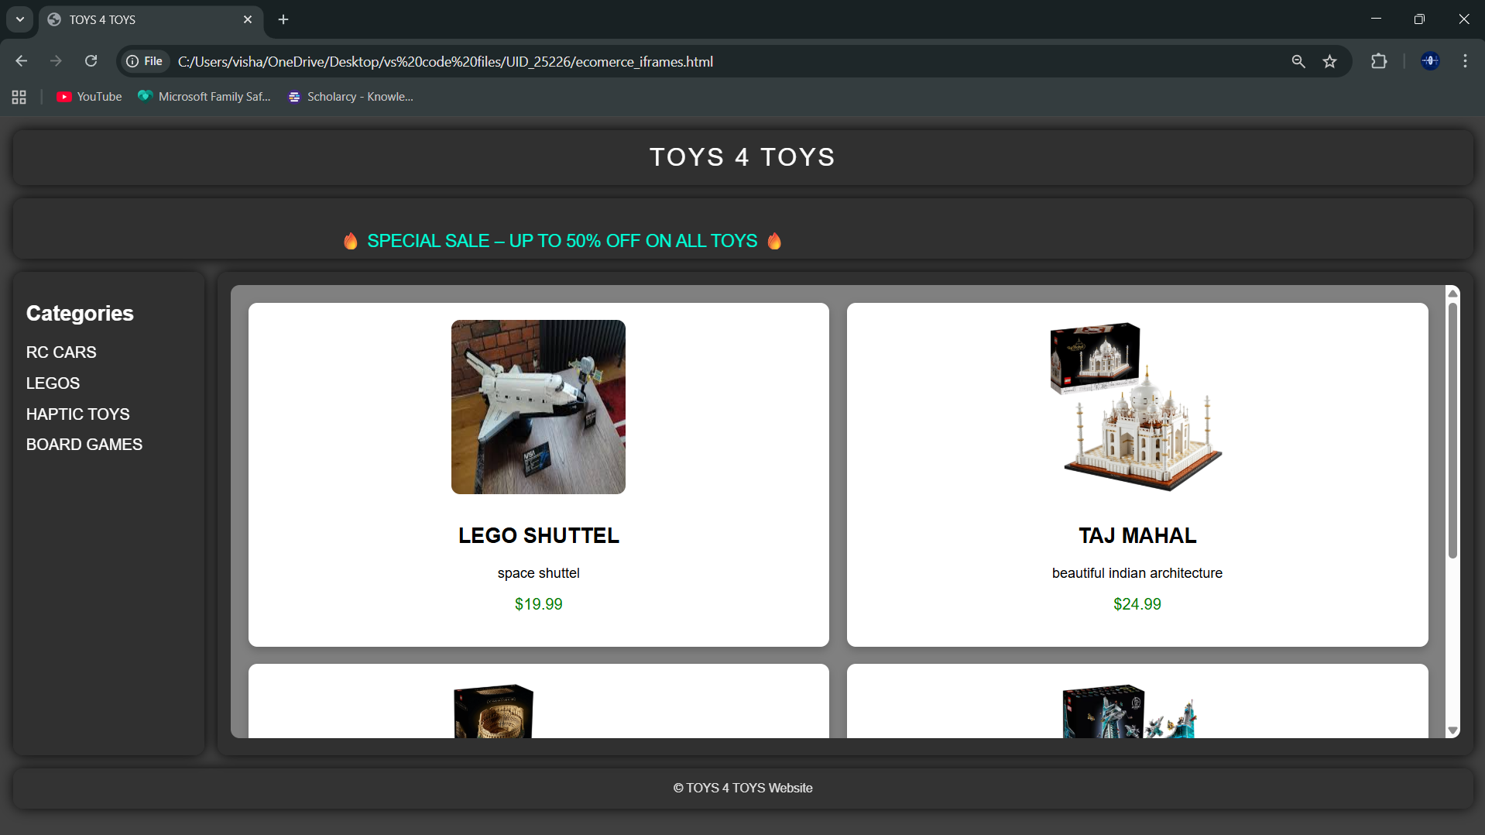
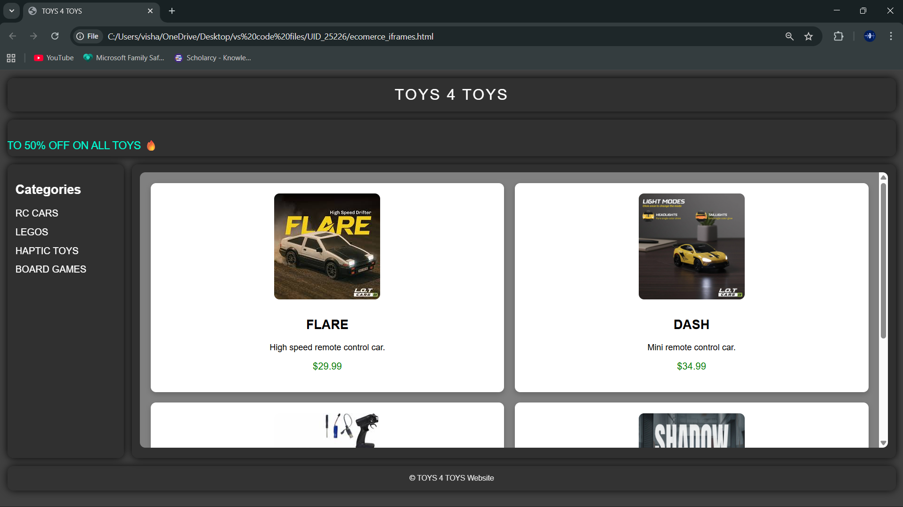
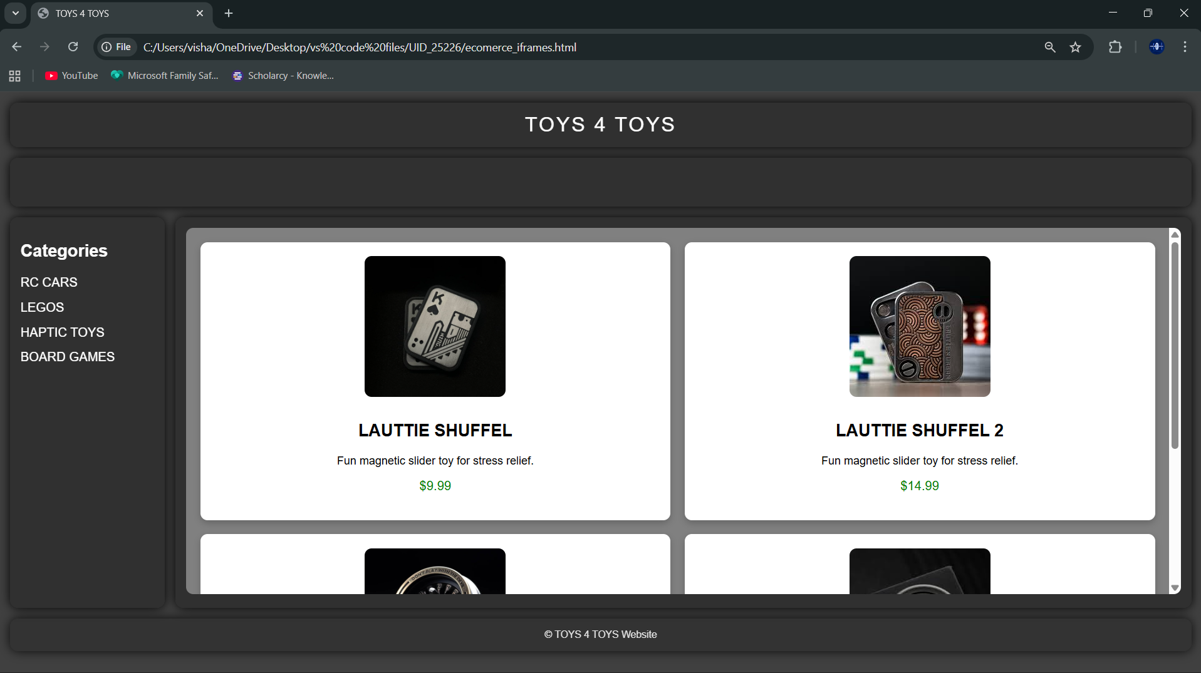
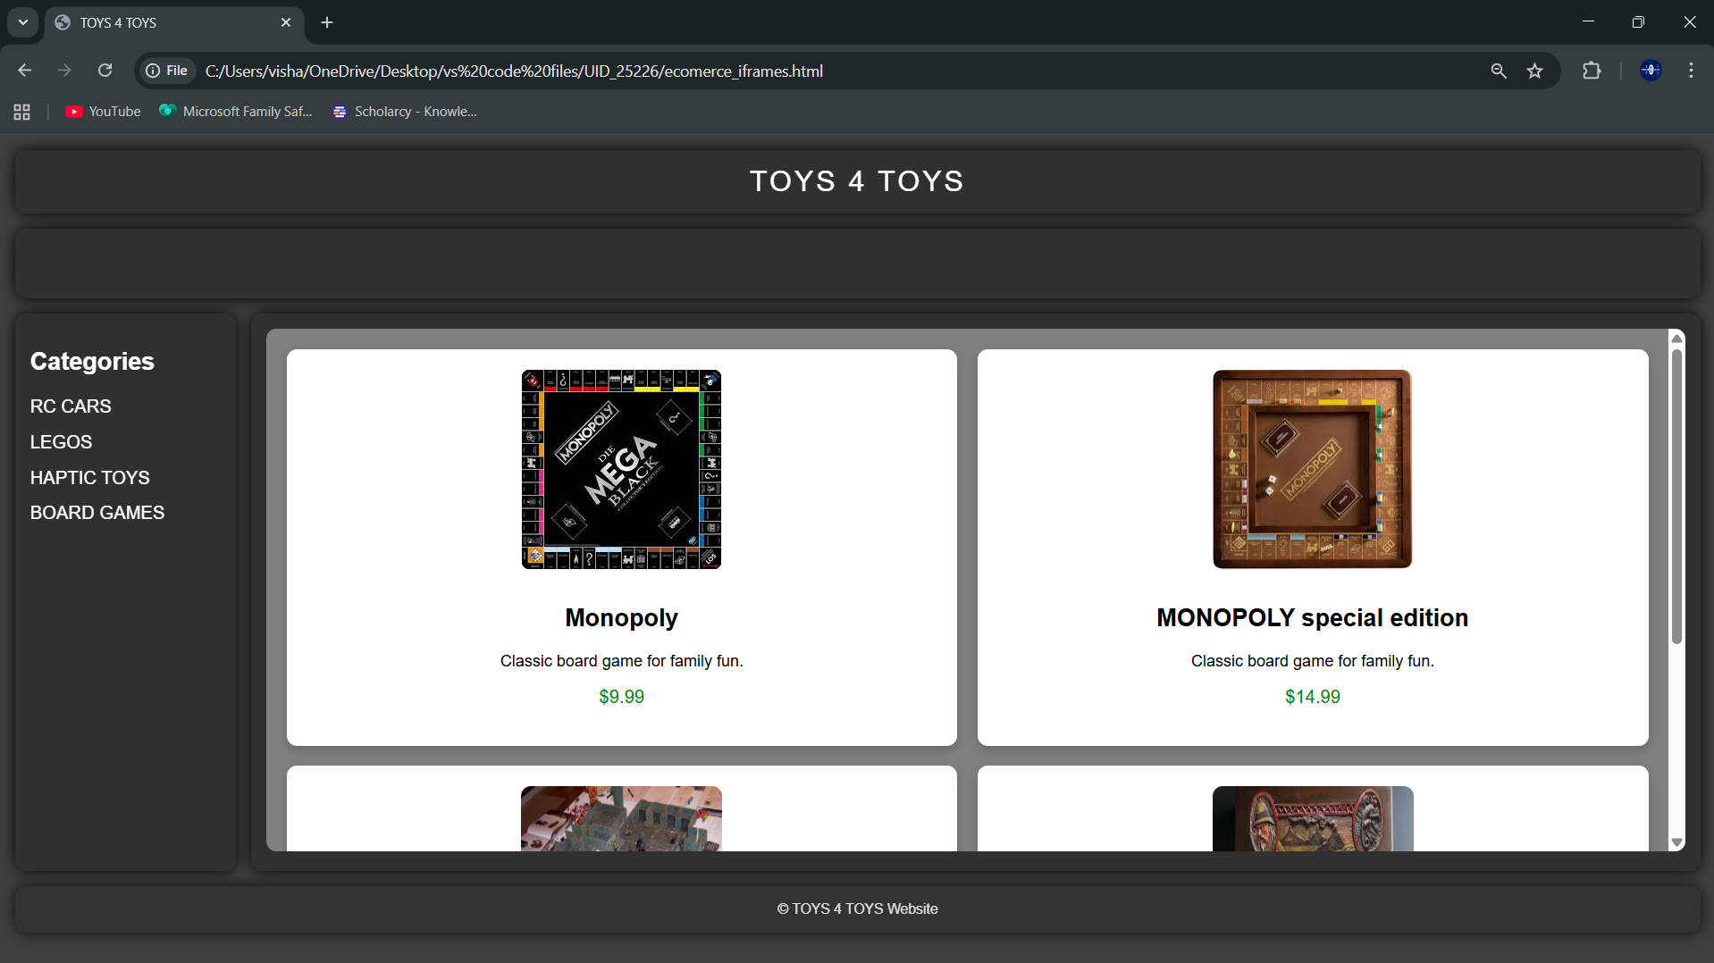
Explanation:
<DOCTYPE html> : the <!DOCTYPE html> element tells the web browser that this an HTML document
or this is the latest version of HTML
<html> : the <html> element is the root element of an HTML web page
<head> : the <head> element will contain meta data about the HTML web page
<title> : the <title> element specifies a title for the HTML Page
<body> : the <body> element contains all visible content all visible content like text , image , links ,
tables , etc
<h> : we used <h> element for heading
<p> : we used <p> element for the paragraph
<div>:we use <div> element for encapsulating the the divisions and easy to modify and
<button>: we use <button> element for button
<img>: we use <img> tag for displaying the image
<I frame>:we <iframe> tag to create link other webpages into it.
We used layout in this program and its attributes like grid-template-rows, grid-template-coloums, grid-template-area to define the items space for the grid layout by dividing page into separate sections and use div tag make into small separate blocks and we used I frames to link the sub webpages into main webpage we attribute target and name for easy understanding and reduce the code .
Week -7:
7.A) Aim: create a GitHub account and create a repository in it and push all the week 6 code files in it.
Procedure :
Step 1: browse for GitHub and enter it.
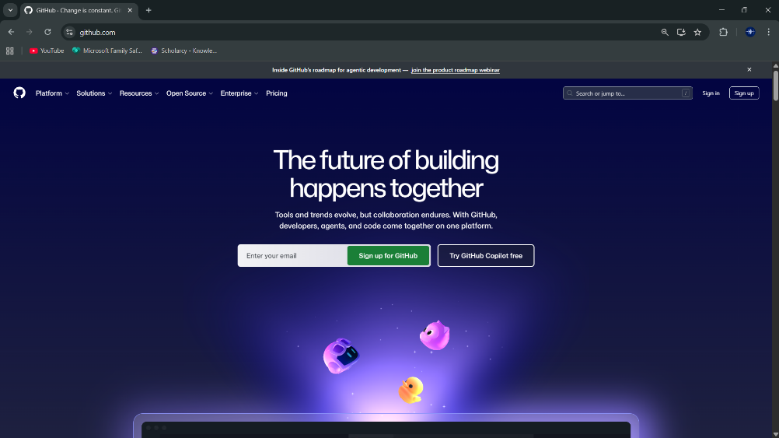
Step 2:login to GitHub account.
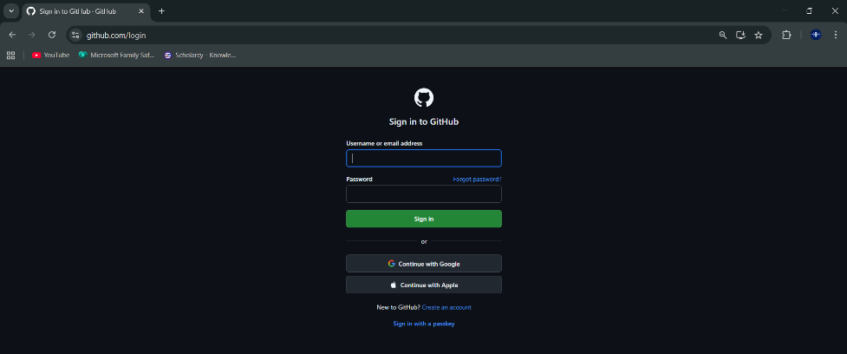
Step 3:create a repository after login by clicking new.
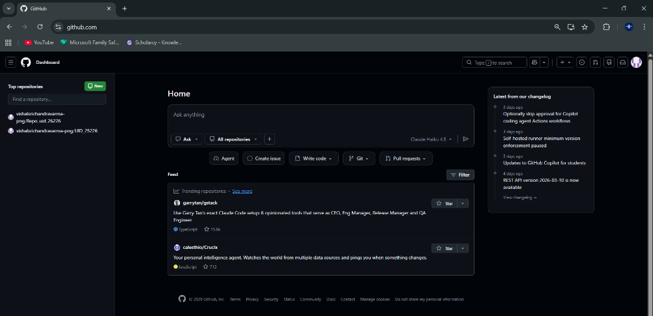
Step 4:specify the repository specifications.
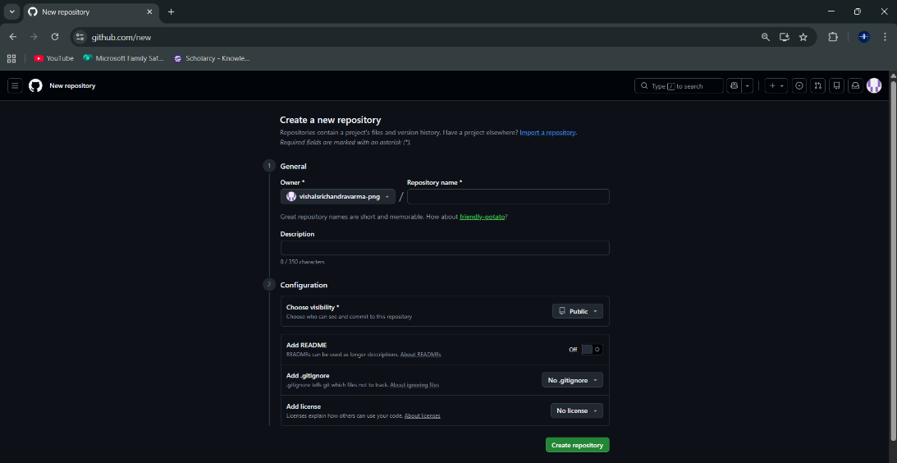
Step 5:download GitHub desktop and Lauch it .
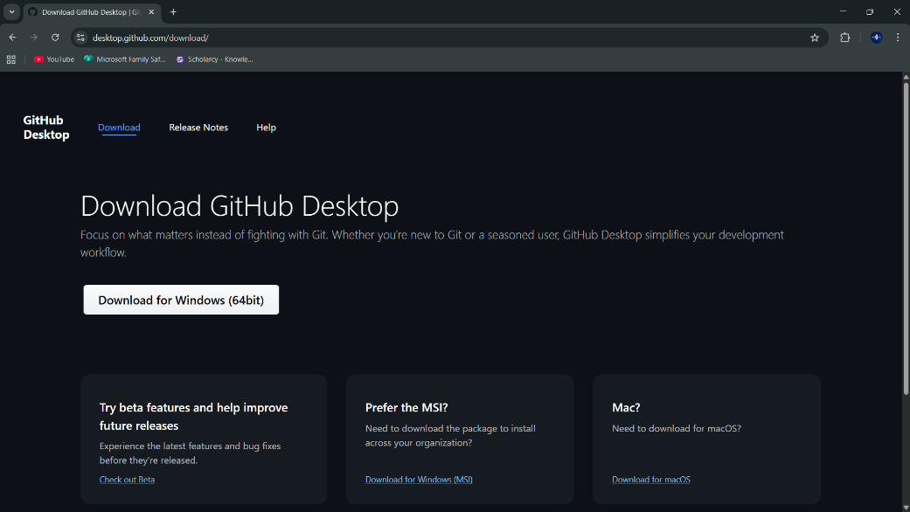
Step 6:add the repository to it .
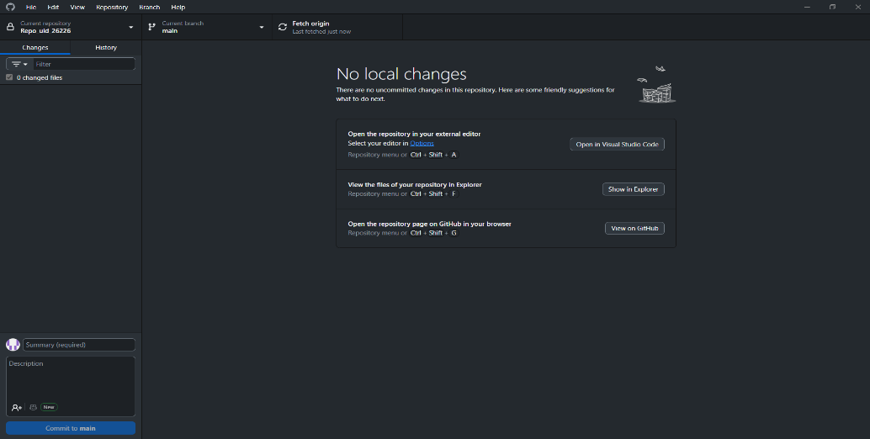
Step 7:add the vs code file to the GitHub desktop.
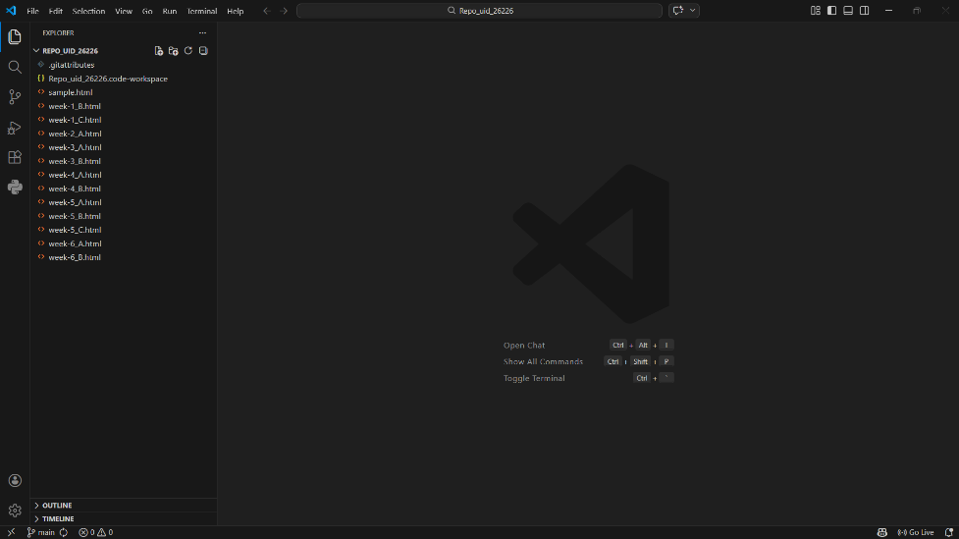
Step 8:add commit to it and the files to repository and sync the changes . it automatically
pushes the files .
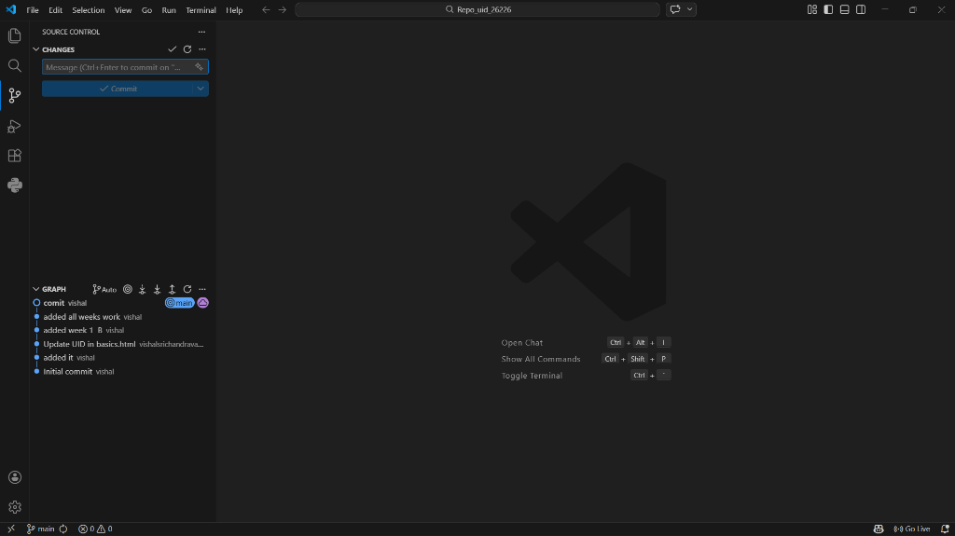
Step 9:now go to browser and check it . it will show all the new added files in the repository .
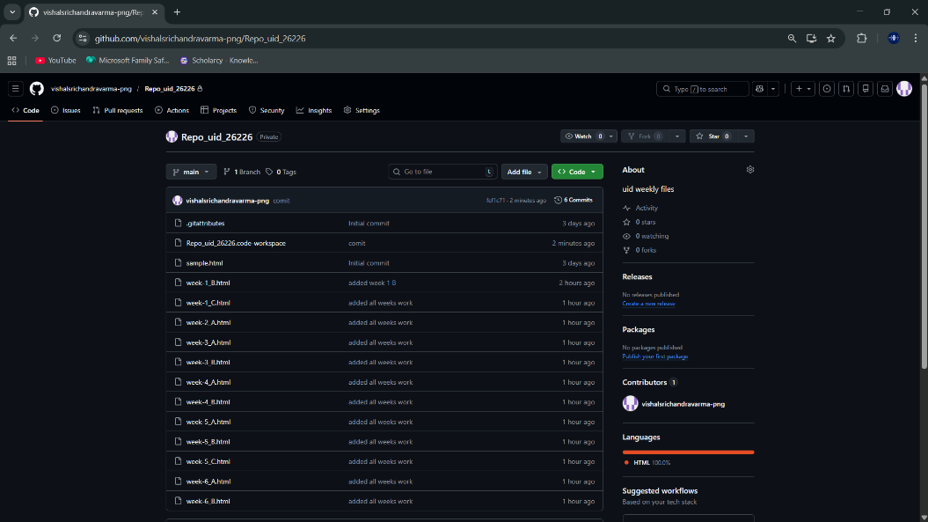
My repository link for the uid all week’s work:
https://github.com/vishalsrichandravarma-png/Repo_uid_26226.git
week 8:
8.A) Aim: create a web page that displays a square that continuously rotates 360 using css animation
Program :
AV.SC.U4CSE25226-UID
<!DOCTYPE html>
<html>
<head>
<title>Rotating Square</title>
<style>
body {
margin: 0;
height: 100vh;
display: flex;
flex-direction: column;
justify-content: flex-start;
align-items: center;
background-color: #2f3e46;
font-family: Arial, sans-serif;
padding-top: 50px;
}
.square {
width: 120px;
height: 120px;
background: #ffffffcc;
border-radius: 12px;
box-shadow: 0 8px 25px rgba(0, 0, 0, 0.2);
animation: rotate 3s linear infinite;
}
@keyframes rotate {
from {
transform: rotate(0deg);
}
to {
transform: rotate(360deg);
}
}
</style>
</head>
<body>
<h1 style="color: #fff;">Rotating Square</h1>
<div class="square"></div>
</body>
</html>

Output:
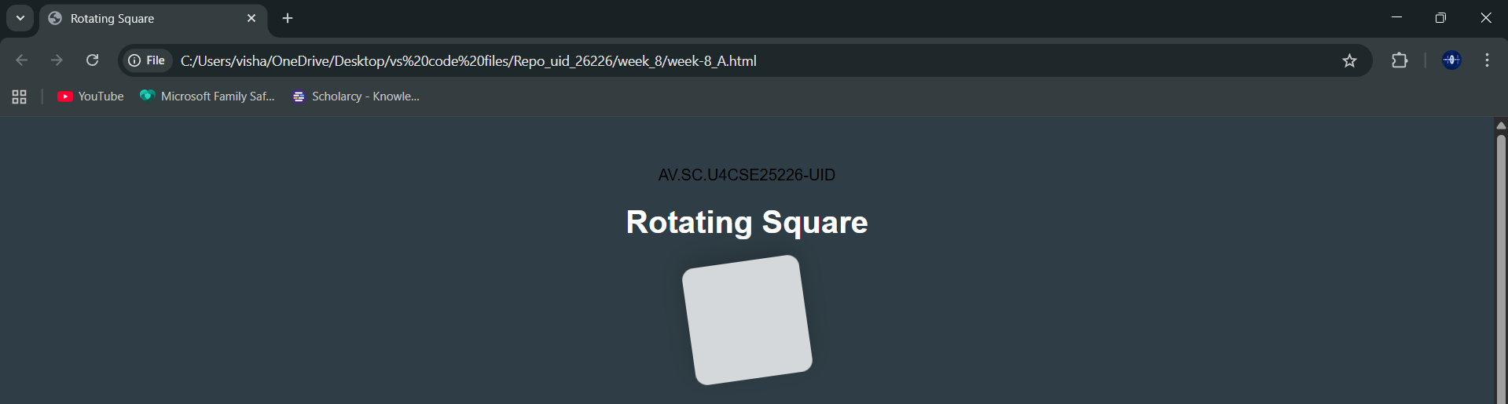
Explanation:
<DOCTYPE html> : the <!DOCTYPE html> element tells the web browser that this an HTML document
or this is the latest version of HTML
<html> : the <html> element is the root element of an HTML web page
<head> : the <head> element will contain meta data about the HTML web page
<title> : the <title> element specifies a title for the HTML Page
<body> : the <body> element contains all visible content all visible content like text , image , links ,
tables , etc
<h> : we used <h> element for heading
<div>:we use <div> element for encapsulating the the divisions and easy to modify and
@keyframes:we use @keyframes for animation from starting to end transformation.
We used animation shorthand property for these things to mention the animations preferences and use keyframes for mentioning the positions of the animation and used style attribute and some value properties for look and we used internal css in it .
8.B)Aim :create a ball that moves up and down continuously using css animation
Program :
AV.SC.U4CSE25226-UID
<!DOCTYPE html>
<html>
<head>
<title>Bouncing Ball</title>
<style>
body {
margin: 0;
height: 100vh;
display: flex;
flex-direction: column;
align-items: center;
justify-content: flex-start;
background: #2f3e46;
}
h1 {
margin-top: 20px;
color: #ffffff;
}
.ball {
width: 80px;
height: 80px;
background: #ffffff;
border-radius: 50%;
margin-top: 120px;
animation: bounce 1.5s ease-in-out infinite;
}
@keyframes bounce {
0% {
transform: translateY(0);
}
50% {
transform: translateY(-120px);
}
100% {
transform: translateY(0);
}
}
</style>
</head>
<body>
<h1>Bouncing Ball</h1>
<div class="ball"></div>
</body>
</html>
Output:
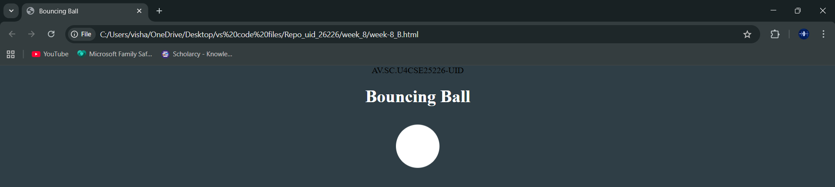
Explanation:
<DOCTYPE html> : the <!DOCTYPE html> element tells the web browser that this an HTML document
or this is the latest version of HTML
<html> : the <html> element is the root element of an HTML web page
<head> : the <head> element will contain meta data about the HTML web page
<title> : the <title> element specifies a title for the HTML Page
<body> : the <body> element contains all visible content all visible content like text , image , links ,
tables , etc
<h> : we used <h> element for heading
<div>:we use <div> element for encapsulating the the divisions and easy to modify and
@keyframes:we use @keyframes for animation from starting to end transformation.
We used animation shorthand property for these things to mention the animations preferences and use keyframes for mentioning the positions of the animation and used style attribute and some value properties for look and we used internal css in it .
8.C)Aim :create a circle that moves horizontally and rotates At the same time
Program:
AV.SC.U4CSE25226-UID
<!DOCTYPE html>
<html lang="en">
<head>
<title>Moving Rotating Circle</title>
<style>
body {
margin: 0;
height: 100vh;
display: flex;
flex-direction: column;
align-items: center;
justify-content: flex-start;
background: #2f3e46;
overflow: hidden;
}
h1 {
margin-top: 20px;
color: #ffffff;
}
.circle {
width: 80px;
height: 80px;
background: #ffffff;
border-radius: 50%;
margin-top: 120px;
animation: moveRotate 3s linear infinite;
}
@keyframes moveRotate {
0% {
transform: translateX(-150px) rotate(0deg);
}
50% {
transform: translateX(150px) rotate(180deg);
}
100% {
transform: translateX(-150px) rotate(360deg);
}
}
</style>
</head>
<body>
<h1>Moving Rotating Circle</h1>

<div class="circle"></div>
</body>
</html>

Output:
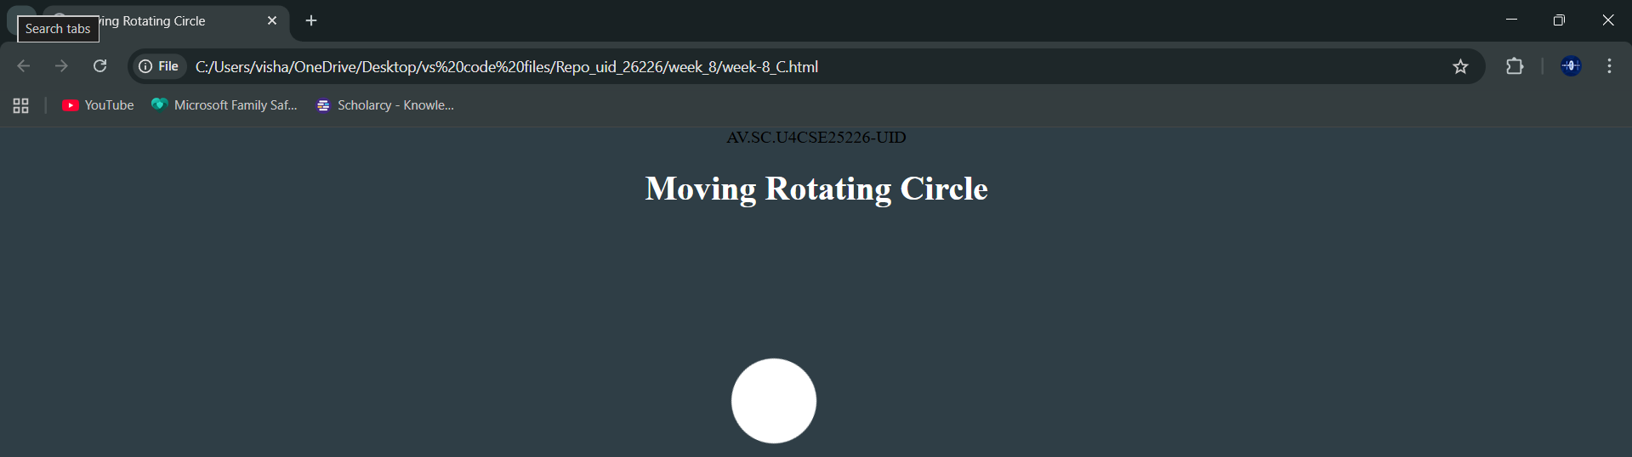
Explanation:
<DOCTYPE html> : the <!DOCTYPE html> element tells the web browser that this an HTML document
or this is the latest version of HTML
<html> : the <html> element is the root element of an HTML web page
<head> : the <head> element will contain meta data about the HTML web page
<title> : the <title> element specifies a title for the HTML Page
<body> : the <body> element contains all visible content all visible content like text , image , links ,
tables , etc
<h> : we used <h> element for heading
<div>:we use <div> element for encapsulating the the divisions and easy to modify and
@keyframes:we use @keyframes for animation from starting to end transformation.
We used animation shorthand property for these things to mention the animations preferences and use keyframes for mentioning the positions of the animation and used style attribute and some value properties for look and we used internal css in it .

